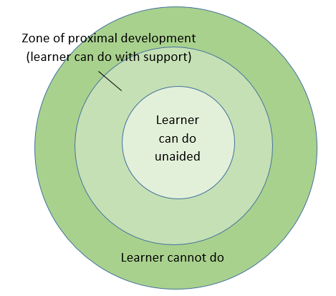
Zone of Proximal Development
The Zone of Proximal Development, the ZPD, is the ‘learning zone’ and scaffolds, concrete, visual or verbal are the supports given to enable learning. We remove the level of scaffolding over time as the learner becomes more proficient and becomes independent, the ZPD then moves out and learning progresses.
No two learners have the same ZPD and for learners with SEND this may be narrow.
What is key is the level of support needed. Too much (because the task is too challenging) the learner may become defeated, overly reliant on adult support, lose confidence, frustrated, become passive and learnt helplessness may set in. Tasks pitched beyond the ZPD compromise learning and genuine success.
When planning a learning task or an outcome in the ZPD it is important to ask
- What are the pre –requisite skills for the task/outcome?
  - Which of these can the learner do unaided?
  - Which are going to require support/scaffold?
  - Is the level of support/scaffold required too much or just about right?
‘Learning’ refers to all aspect of learning; academic, social, emotional, communication & language, physical.

Visual, verbal and concrete scaffolds are important and the aim is that the learner uses these with minimal prompting (he learns what helps him to learn!) and that over time these are removed (scaffolds are temporary structures) and he can do the task unaided.

