SEMH Guide ‘Self-Esteem and Confidence Building’

Introduction:
Self-esteem refers to how a person views and values themselves. It involves having a positive opinion about your own worth, abilities and qualities. When someone has healthy self-esteem, they feel confident, capable, and deserving of love and respect. Self-esteem and confidence building is important to emotional development, mental health, and wellbeing. Exploring healthy self-esteem strategies improves mental health and wellbeing. The self-esteem activities help support confidence building.
Visual resources can be used to support positive thinking and as a reminder of self-esteem building activities. These visual prompts can be used to help a child/young person develop a personal took-kit to improve self-esteem and confidence when feeling stressed or anxious.

Strategy:
Step 1: The first part of the work consists of identifying activities to support emotional wellbeing and self-esteem awareness:  - Identify own strengths and differences.  - Journalling  - Positive affirmations and negative thoughts  - Physical activities  - Practising gratitude  Explore healthy thinking example:  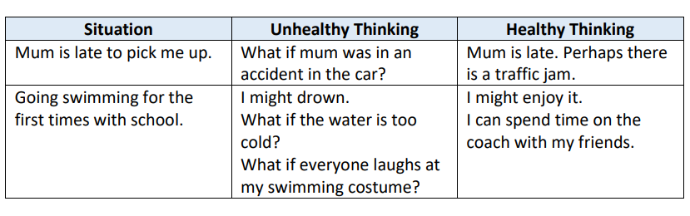  A child or young person can develop their own personal toolkit to improving self-esteem and carry a visual prompt card as a reminder.  Positive Affirmation example:  Positive affirmations can target specific beliefs through -  - short, positive statements.  - Challenge and undermine negative beliefs.  - replace negative beliefs through self-nurturing beliefs.  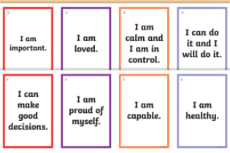 | Step 2: When activities have explored self-confidence and self-esteem. Developing individual positive coping strategies can be identified through ‘Ways, I can help myself’ and ‘Ways adults can help’. Here we list agreed strategies that the student can use to build confidence and regulate:  - Being kind to self  - Learn to say ‘no’  - Practise positive affirmations.  - Learn to be assertive.  - Give yourself a challenge.  - Build positive relationships.  - Practise conversational skills.  Example of personalised strategy cards to build confidence in conversational skills:  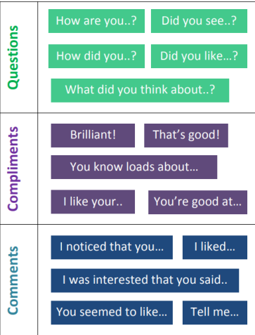
Step 3: The strategy card can be personalised, laminated and minimised so that it fits into the student’s planner or is used as a visual support on their workstation. Staff can then use the ‘self-confidence reminder’ when ‘checking in’ with the student throughout the school day e.g., asking the student to use this as a prompt and reminding the student of the strategies needed to improve confidence.

Resources and Links
Self-esteem resources  ELSA Self Esteem Teen intervention- 6 sessions for ages 11-16  Rise and Thrive Teen self-esteem intervention - Item 591 - Elsa Support (elsa-support.co.uk)  Score self-esteem example:  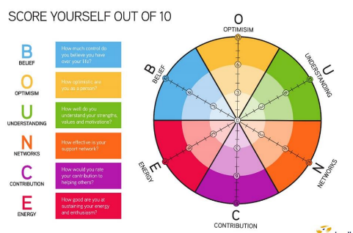 | Example of visuals to support self-esteem strategy cards:  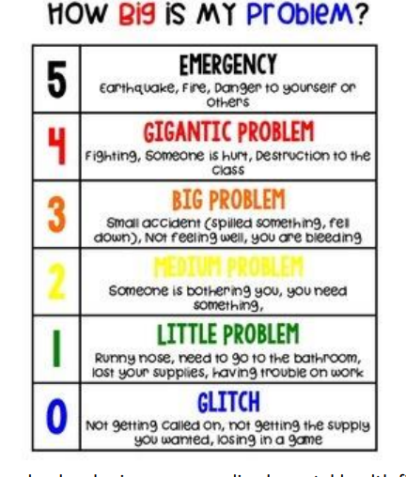 | The self-esteem (Book):  A cognitive behavioural therapy for self esteem  