Large print maths equipment



www.positiveeye.co.uk

List of early years/primary mathematics resources
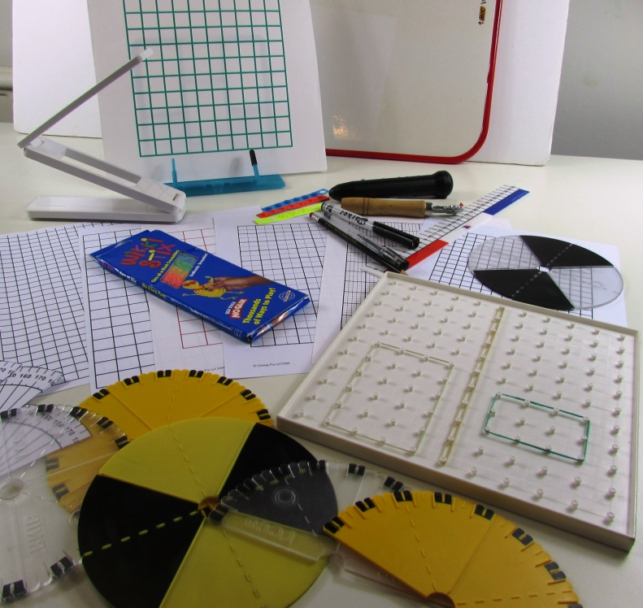
- 100 squares either in enlarged print or overlaid in Braille - adapt/make your own using velcro strips
- A range of number lines and cards in enlarged print or overlaid in Braille - make and adapt own
- Flip-chart number lines for single recognition - enlarged or Braille (alternative to number fan for young Braille users)
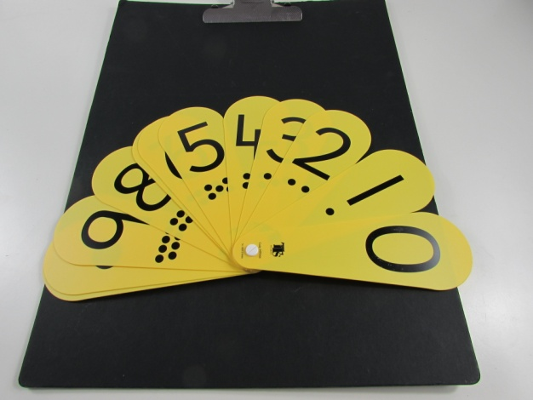
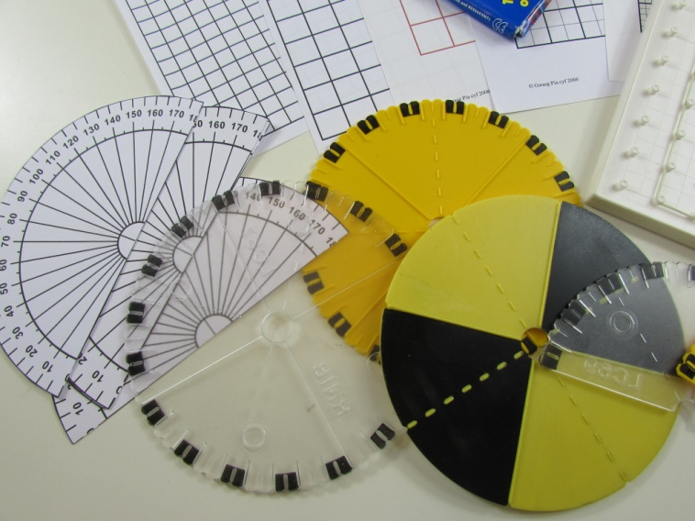

TTS Educational Suppliers
www.tts.co.uk
- An individual number fan for the pupil – if child is partially sighted matt ones are better than glossy.
- Large print number fan for class teacher. ( if child is partially sighted) 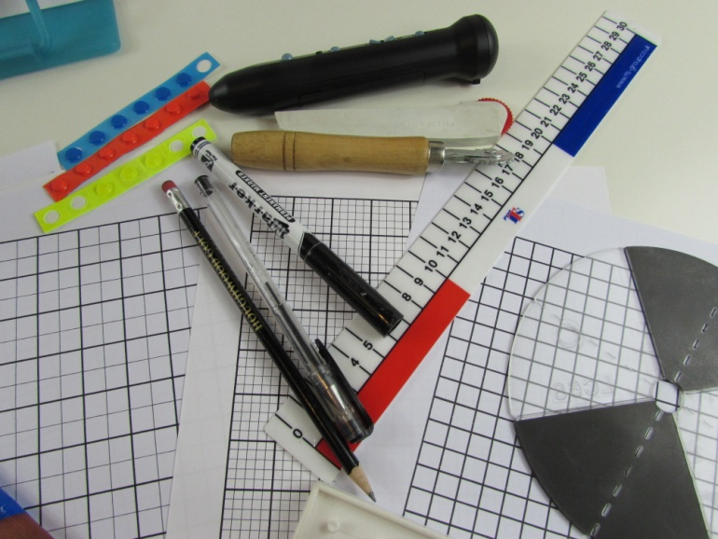
- Large learning clock (add tactile markings – adapt)
- A4 whiteboard
- Large print rulers – Early Stage Ruler

RNIB
www.rnib.org.uk
- Braille watch
- Timer with speech access
- Tactile dice
- Set of 3D shapes
- Set of 2D felt shapes
- Wikki Stix – RNIB or Hobbycraft http://www.hobbycraft.co.uk/
- Bumpons - in a range of sizes, colours and shapes (eg square and circle). Great for points on maps, marking places on diagrams etc.
Geometry mat and embossing film, spur wheels (Amazon- Type in Overstitch-Leather-Perforating Roulette)

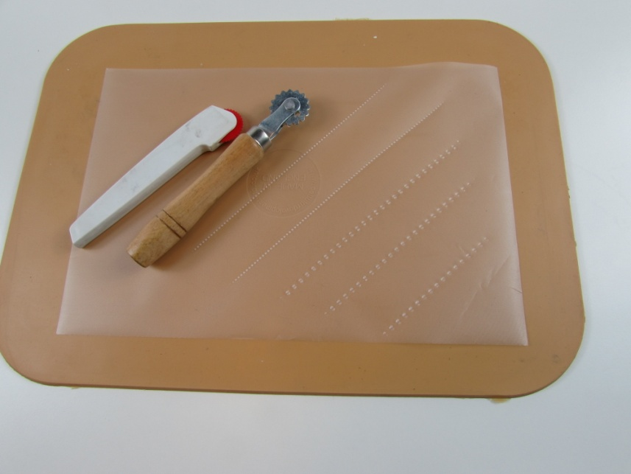

- Tactile rulers and protractors and metre stick, tape measure with Braille measurements
- Large display calculator and calculator with speech
- Cubarithm - ideal for showing an immediate demonstration of computation layout to a braillist -
- Abacus

IKEA
www.ikea.com
- Scarf Hanger (£4.50)
- Lazy Sue (£5.50)
- Collection of square, rectangular trays
- Mouse mats for fraction activity
- Green circular mats for Maths activities
- Laptop tray – turned upside down to make work station
- Red chopping board (used for sorting activity) (2 x £1.00)
- Large black A3 clip board

Amazon
www.amazon.co.uk
- Animal models – Schleich (Amazon)
- Shells – Amazon
- Abacus beads – Amazon

B&Q
www.diy.com
- Tape used for dividing sections on chopping boards, (bath sealant edging – sticky back from B&Q)
- Shelving for supermarket from B&Q £20.00 for four shelves
- Tile number square – floor tile – B&Q

Various
- Large containers (supermarket) empty protein builder product – health food shop
- Small boxes various shapes – Wedding favour boxes www.partydelights.co.uk
- Hello Kitty and Tea Set – B&M Bargains
- Real coins
- A range of beads in different shapes: snap beads, threading beads
- Concrete counting resources such as Multilink
- A set of Lego
- Sand, food colouring, water and a range of clear bottles/containers for showing capacity
- Large squared exercise books (Partially Sighted Society Doncaster)
- Sorting trays – different shaped counters, beads, bricks – Pound Shop
- Elastic bands
- Gripping stuff (Sticky memo strip or memo board, good to put on tray or on surface to stop activity moving around) www.grippingstuff.com
- Fun animal buzzers – Learning Resources. http://www.learningresources.co.uk/
- Foam board used for number lines and tray interchangeable bases – Hobbycraft
- Thick straws with pumpkins – Hobbycraft (Hallowen time)

