SEMH Simple ‘How to’ Guide…

‘Supportive environments’

Introduction:
Every classroom should be designed to help support all young people to thrive. With the diverse needs and range of abilities within our classrooms, there is often the need to make adaptations to reduce the anxiety, anger or distress that some young people may experience. Classrooms where students respect and pay attention to each other’s thoughts, and feel safe to express their own thoughts, are more productive for learning. Where students cooperate with each other effectively, they are able to benefit from learning interactions with their peers. Students who are motivated to study, learn, engage and succeed are more likely to do so, and feelings of autonomy, competence and relatedness can help to promote learning. Creating a positive classroom environment can remind our children that the classroom is a safe space.

Strategy:
Step 1:  Ideally, the first step would be to assess the effectiveness of the current classroom for all students; followed by additional consideration for any specific pupils whose current presentation may be communicating the need for additional measures to be provided.  Questions that may be helpful:  - what parts of the classroom are un/ helpful?  - what areas of the classroom are over/ underused?  - does the layout of the classroom promote collaboration and healthy relationships?  - what is it that the children are asking for? What is their un/ intentional feedback throughout the school day?  - how are your expectations communicated and do all children understand these?  - what are the behaviours observed which are communicating frustration and what are they telling us? (This may require use of the How-to RAGE rate guide)  - what would help meet the needs of the young people who are currently finding the environment difficult to access/ manage?  - what support is available to support pupils academically and is this readily available?  - what support is available for pupils with SEMH needs and how is this provided?  - what support is in place for pupils with SEND including HI/ VI?  - what do classroom staff feel is needed to help them to support specific pupils?  - what would be the purpose of any changes?  - what are you hoping to achieve through the adaptations you make?  - what is already available to support pupils and why is it un/successful?  - has a sensory environmental checklist been completed?  - have alternative entrance and exit points to the classroom being considered to reduce any possible triggers resulting from being overwhelmed?  - are spaces and resources clearly labelled using readable texts, with additional visual supports to aid independence and reduce anxiety? | Step 2:  Deciding what to change and when to change it will be a result of a discussion between key adults in school. It is essential to consider how these changes will be communicated to the students, so they know the purpose and intention of these things happening.  This could be done by:  - involving the children in the process by gaining pupil voice and asking them for their suggestions.  - helping them prepare for change by giving them advance warning of what will change, when it will change and why it is changing.  - allocating time to talk through the whys and the how’s; it is incredibly important that the children know what the changes are being made for and how they are intended to be used.  - considering any individuals who may need this to be explained on a 1:1 basis when the classroom is empty so they have time to explore and familiarise themselves with the change with the chance to ask any questions to their trusted adult.  - Use of a plan of the class a child can draw on with any additional suggestions or feedback that could be used to inform next steps?
Step 3:
We can not assume that by making these changes, the children will automatically manage better and make use of the adaptations that has been required and so careful monitoring needs to be undertaken in order to assess the level of effectiveness and success which may then lead to additional adaptations/ tweaks being made.
Monitoring could be conducted through:
RAG rating different areas/ aspects of the classroom to see when they are used, how they are used, who they are used by, how the young people feel before and after making use of the area, when it is used un/ successfully.
Outcomes from ongoing monitoring and analysis will then help to make changes that may be required.

Resources and Links
Blank template:  Environment sensory checklist.  Successes/ challenges/ next steps proforma.  RAG rating How to guide. | Examples of completed:  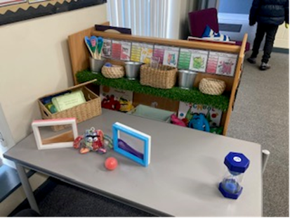  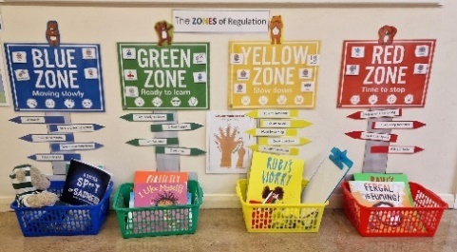 | Example of visuals to support:  Visual timetable.  Now/ next/ then.  Class/ group/ individual task boards.  Zones of regulation.  Emotional ‘toolkit’ suggestions.  Purposeful working wall with relevant scaffolds to support learning.  Discreet methods of communicating when help is needed.
Book/ links:
https://positiveyoungmind.com/reasonable-adjustment/
https://www.cambslearntogether.co.uk/cambridgeshire-send/cambridgeshire-send-oap-toolkits/ey-toolkit/social-emotional-and-mental-health-semh/enabling-environments

