SEMH Simple ‘How to’ Guide…

‘Safe Spaces’

Introduction
A safe space is a designated area that is used by someone who is feeling overwhelmed by their emotions and needs some time away from intense or difficult situations to calm. Children who are feeling anxious, angry, upset, afraid or even excited may benefit from having a private space that they can go to for some time to regulate their emotions. It provides a calm, low stimulation environment and is an asset in busy classrooms. Safe spaces can help where there is a wide range of needs amongst students. They can be used as part of an individual’s crisis management plan. It can help reduce the number of crisis situations as it can offer a less restrictive option than manual “holding” to prevent physical injury to others from an unsettled pupil. Safe spaces serve every kind of pupil. For some, the space might give them a brief pause from a tough day. For others, it can be so much more. Safe spaces are often cited for helping those suffering from intense levels of stress or trauma. They are essential to every classroom because children cannot learn when they do not feel safe. A safe space, also known as a calming area, is easy to set up and does not have to be costly. It can be a very effective strategy when used well and is often recommended for children who find it difficult to self-regulate.

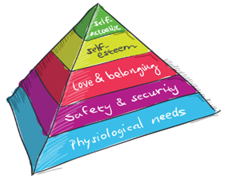

Strategy:
Step 1:  Set Up A Safe Space  Where possible, educators should discuss the safe space with their class before setting it up. By involving pupils in the planning and designing of the calming area, we are enabling them to feel a sense of ownership. They will then want to take care of it and respect those who choose to use it. We want to help children to understand that they’re not at fault for having lots of conflicting emotions and that these emotions are common to everyone, regardless of age, ability, or background.  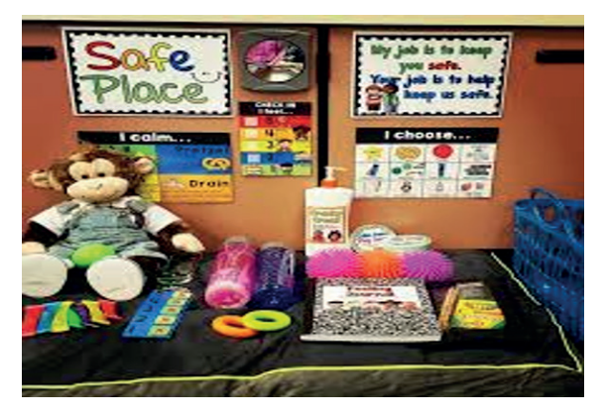 | Step 2:  Use A Safe Space  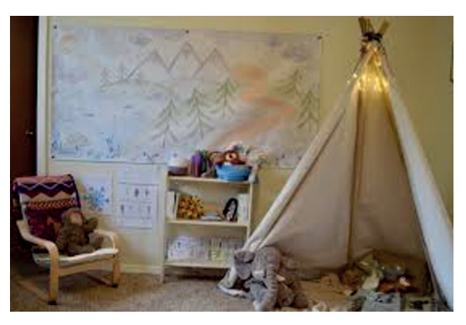  There are several factors to consider when using a safe space. There is no clear way of using a calming area and the approach to using this space will differ from child to child. It may also differ from one incident to the next. For some children, it will be used as a preventative measure and for others, it will be an end point. The key is to educate the class on the benefits of the safe space. Let them know when to use it and the cues that might indicate they to take need a break. Encourage them to choose the designated area to regulate and then return to the classroom activity when they feel ready. Once pupils see that it is okay and “normal” to get upset or need a break, they begin using safe spaces voluntarily for their own unique needs. This is social-emotional learning in action. We must also emphasise that it is not a punishment, rather a choice.

Step 3:
The Safe Space To Prevent A Crisis
With some pupils, it can be easy to identify when they are feeling unsettled. They may start to fidget, they may become non-verbal, they may start to line up stationary, or they may hide. At this point, a trusted member of staff would step alongside the pupil and try and identify the trigger and address it. If the pupil will not engage, offer them a way out of the situation by asking if they’d like to stay where they are or to use the safe space. By providing a closed choice, children will feel as though they have a sense of control. In the majority of cases, the child will choose to go into the calming area.
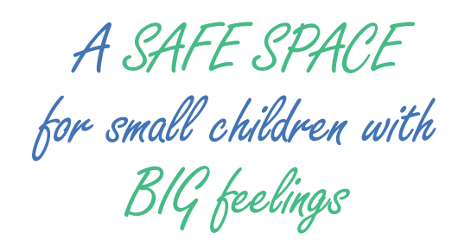

Resources and Links
Website Links and Resources:
http://www.safespaces.co.uk/safespaces-films
3535f-JH-How-to-create-and-use-a-Safe-Space-in-schools.pdf (educationgateshead.org)
