SEMH IST Simple ‘How to’ Guide…

‘RAG Rating’

Introduction:
A ‘Red, Amber, Green (RAG) Rating’ approach is designed to help staff monitor and identify possible triggers and ‘tools’ that can be used to help reduce the anxiety, anger or distress that a young person is experiencing. RAG rating techniques can used as a benchmark to help indicate where a young person’s ability to manage is more/ less successful which then allows staff to further explore reasons behind patterns that may then be identified. Using a RAG rating system to assess risk means that different situations can be ranked so that the most severe are addressed first; leading to decisions then being made relating to actions which can be taken to alleviate/ minimise the risk.
Strategy:
Step 1:  Key staff must first collaborate to decide what actions/ behaviours/ incidents the different colours represent- which will be different depending on the needs and presenting behaviours of the child. It is recommended that for any aspects of the school day which are rated Amber or Red; staff also make note of the potential trigger and the ‘tool’ that was used to support the young person to regulate. | Step 2:  Depending on the severity of the situation and the level of risk currently facing the young person/ setting, the regularity of coming back together as a ‘Team around the child’ to look at outcomes from the RAG rating, may be more/ less frequent.  Using this approach will help key staff to draw conclusions by identifying patterns which help them to explore the how and why.  RAG rating may help to identify possible causes leading to the young person becoming dysregulated which could include:  - a day of the week  - a specific time of the day  - a lesson  - a member of staff  - certain events being held in school  - certain events happening at home  - transitions  - their understanding/ interpretation of instructions  - the impact of rewards/ sanctions  - completing work  - the pupils they are spending time with
Step 3:
Once the ‘Team around the child’ has identified something they feel may be impacting on the young person; this can then be explored in more detail by adopting a curious approach to the discussion (Please see link to Making meaning of SEMH for a suggested structure to the discussion and possible questions to ask). Through this, key adults can then look at what they can put in place to support the young person.

Limited examples
Possible trigger |  | Questions
A day of the week |  | - what day of the week is it?  - what happens on this day?  - what happens before this day?  - how does the day begin?  - what happens at the end of this day?  - what happens the day after?  - is this particular day important/ traumatic for any reason?  - what staff members are present/ absent?  - is there anything different that happens on this day?
Completing work |  | - does this happen in every lesson?  - in what lessons does this become a problem?  - what type of tasks are more/ less successful?  - are the activities pitched appropriately?  - is the task achievable?  - how has the task been explained?  - what aspects of the task are in/ complete?  - what reasons does the young person give for not completing them?  - how does the young person ask for help?  - what support is offered and does it make a difference?  - what happens if the task is in/ complete and is this something the young person wants to happen?
A member of staff |  | who is the member of staff?  - what is their role?  - does the child know the adult for any other reason other than school?  - what has been their past relationship in school?  - has the member of staff taught any of the pupil’s family members and what were their relationships like?  - how have previous interactions been?  - are there any incidents where the pupil and member of staff were both involved?  - is the pupils’ reaction to this member of staff the same every time?  - does the young person explain how they feel and why?  - does the adult remind them of someone or something?  - how does the member of staff speak/ interact with the pupil and could this affect the way they feel (this may be unintentional)?  - has the member of staff had to manage a difficult situation involving this young person which could have affected their relationship?  - for what reason does the young person spend time with the member of staff and could this be a factor?

Resources and Links
Blank template:The teacher’s daily/ weekly timetable should be used so that the specific structure of each day is then able to be monitored. | Completed examples:  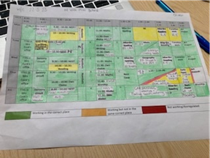  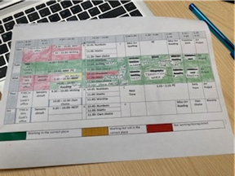 | 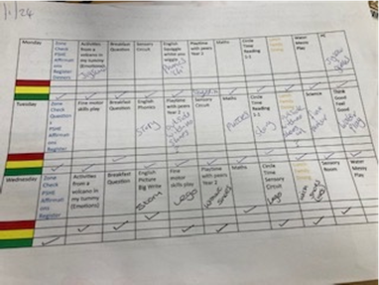  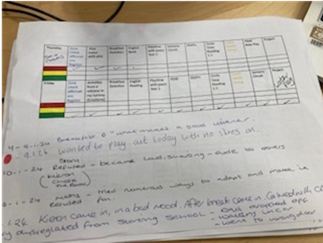

Resources:
Making meaning of SEMH- offer to schools:
file:///C:/Users/TSA16571/AppData/Local/Temp/MicrosoftEdgeDownloads/30407215-c5ed-48b4-a1b5-a3219d457401/Making%20Meaning%20of%20SEMH%20Primary%20Offer.pdf

Key questions:

