STARS Introduction to Visual Supports
(to support executive function)

Introduction
What is executive functioning?
Executive functioning is a term used to describe a range of mental skills that allow us to manage daily tasks and get things done. Some research suggests that up to 80% of Autistic people have differences with their executive functioning. Anxiety and emotional dysregulation also affect executive function. This can lead to difficulties with managing time and completing tasks, as well as making what might appear to be simple activities (such as getting dressed) very complicated. Each individual will have a unique set of executive functioning strengths and differences.
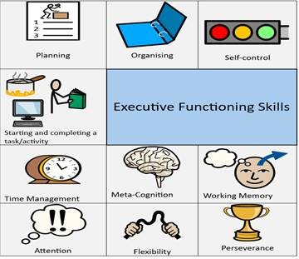

Executive functioning skills
- Organisation: planning and prioritising
- Working memory: retaining, and recalling information
- Initiating and switching between tasks
- Flexible thinking, problem solving and reasoning
- Time management, attention, and focus
- Self-regulation, self-monitoring, and impulse control.

How can visual supports help?
Differences with executive functioning can make learning, social experiences and daily activities challenging. Visual systems and strategies help with information processing, the development of independence and life skills, and remove barriers. Visuals are non-fade, support language understanding, and can promote engagement. Remember, a picture is worth a thousand words!
Visual systems to support executive function work best when used in an enabling environment (with reduced social and sensory demands) and alongside effective communication from adults (that allows for processing time).

Strategies
Visual strategies can be used at a universal, targeted and personalised level. As with any strategy, visuals should be person-centred and strength-based. Consideration should be given to the developmental stage of each child and young person (CYP), their interests, sensory profile and preferred method of communication and engagement: for instance, pictorial representation, photographs, objects of reference, the written word.

Assess
You should aim to gather pupil voice to inform approaches.

Plan/Do
Visual approaches can include (but are not limited to):
- Class, group and individual timetables (static or travelling) and student planners
- Environmental signage
- Clearly ordered and labelled learning environments
- Sequence boards (Jigs)
- Choose boards
- Start and Finish boxes
- Task sheets, steps-to-success, and visually providing a clear beginning, middle and end to tasks
- Showing what ‘finished’ looks like
- Colour-coding to highlight essential and non-essential tasks and allocating time to plan and prepare for each transition
- The use of timers
- Adapted worksheets showing only key information to avoid information overload
- Equipment lists and transparent pencil cases
- Visuals to support short-term memory and chunking of information
- Visual resources to support mentoring
- Visual supports for gathering pupil voice.

Resources and Links
STARS Introduction to Pupil Voice
Communication tips and strategies: how to make and use visual supports
Communication tips and strategies: visual schedules
Communication tips and strategies: choosing a visual support
Amaze: Executive-functioning-tips-for-Autistic-teens.pdf (amaze.org.au)
Bridging the Neurodivide: Exectuive Function (bridgingtheneurodivide.com)
Embrace Autism: Executive challenges in autism & ADHD (embrace-autism.com)
Loren Snow: What is Working Memory?
North East Autism Society: Executive Functioning (ne-as.org.uk)
STARS training on using visual supports

References
Autism and executive functioning skills - Leicestershire Partnership NHS Trust (leicspart.nhs.uk)

See Third Party Disclaimer

