STARS introduction to mentoring sessions (primary)
Introduction
What is ‘mentoring’?

- Mentoring is a bespoke, person-centred support session, delivered by a designated 'mentor'.
- A ‘mentor’ is an assigned member of staff, who has a positive and trusting relationship with the child or young person (CYP).
- The mentor should understand the '3 areas of difference' and how this informs the CYPs profile.
- The mentor should be supported by the SENCo to utilise autism-specific approaches and strategies.
- Usually, mentoring sessions will be delivered on a 1:1 basis, but can also be designed for a small group (if the CYP feels comfortable with this).
- Mentoring sessions are not ‘interventions’, but a space for the CYP to receive guidance and support around their individual needs and goals.
- Mentoring sessions should not be focused on reflective conversations about behaviour, unless the CYP specifically asks to do this.

What is the purpose of mentoring?
- It supports the development of a positive and trusting relationship between the CYP and staff.
- It provides a space for the CYP to share their thoughts.
- An opportunity to work collaboratively with the CYP to find solutions and develop strategies to support their needs.
- Time to plan or prepare for upcoming events (such as, transitions or school trips).
- A time to work through targeted resources or key topics with the CYP (for instance, self-esteem, e-safety, emotional regulation, social knowledge, or exploring their autistic identity*).
*Please note- Parental consent is required to provide the CYP with support and resources on autism.

Strategies
Setting up sessions
- SENCo, key staff and parents/carers to work collaboratively to consider:
- Would the CYP benefit from mentoring sessions at school? If so, what might they look like? Don’t feel like you have to be sat down completing worksheets; some CYP like to ‘walk and talk’ or find it easier to engage whilst playing a game or through their special interest.
- Who would be the ideal member of staff to act as mentor? It is important that the mentor knows the CYP well and can adapt their communication style, body language, and session content to suit the CYP’s strengths, needs and preferences.
- Areas of focus Remember, mentoring sessions should be focused on the CYP’s views, wishes and aspirations. Therefore, offer choice around session topics, activities, and the order in which they are completed.
- When and how often mentoring sessions will take place. The frequency and duration of sessions will depend on the individual’s needs, though it is usually recommended that the CYP has at least one mentoring session per week (avoid scheduling the sessions during a lesson they enjoy).
- How long each mentoring session will last; it may also be helpful to discuss timings for individual activities within the session.
- Propose the idea of mentoring sessions to the CYP and work collaboratively with them to plan, schedule and design sessions:
  - For instance, propose the idea of mentoring sessions to the CYP using a Social Story or invitation letter.
  - Listen and respond to the young person’s thoughts regarding who their mentor may be; where, when, and for how long sessions will take place (some CYP may not feel comfortable using the ‘SEN room’ and might worry about their peers seeing them).
  - Discuss accommodations to support sensory needs (lights switched off, air conditioning/heaters switched off, blinds down).
  - How the CYP would like to get to mentoring (collected from class or making their own way).
  - What sessions involve (topics/activities to cover and topics/activities to avoid).
Top tips for sessions
  - Incorporate appropriate sensory tools and movement breaks.
  - Watch out for indicators of the CYP becoming anxious/dysregulated.
  - It is advisable that sessions follow a clear and predictable structure, supported by visuals.
  - CYP should also be given choice over what will be covered and in what order.
Visual timetables provide structure and predictability:
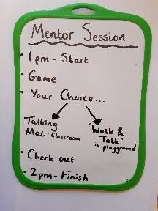
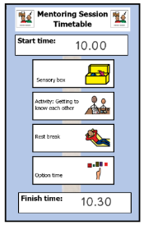

Visual tools support the CYP to
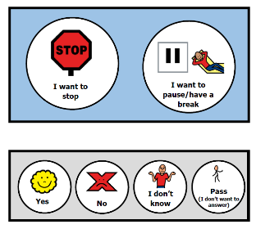
self-advocate during the mentoring session:
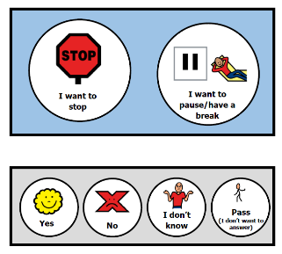

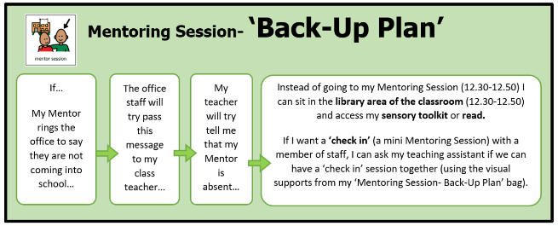
An agreed ‘back-up plan’ for if their mentor is absent from school or the session can’t go ahead. The CYP can have hard copy in their planner and all staff should be aware of the plan:
Resources and Links
For additional information on supporting the CYP to share their ‘pupil voice’, please see Introduction to Pupil Voice.
See third party disclaimer

