STARS Introduction to Mentoring (secondary and post-16)

Introduction
What is mentoring? Mentoring is a 1:1 engagement between a young person (YP) (the mentee) and a more experienced individual/designated staff member (the mentor). It should be a non-judgemental process facilitated by a key adult to discuss the child or YP’s thoughts, fears, and aspirations. It is not an intervention and should not be used as a vehicle for ‘unpicking’ or focusing on behaviour.
Why does it work?
- Facilitates and builds self-advocacy and independence.
- Builds connections with key adults thus reducing potential isolation.
- Promotes wellbeing, self-worth, and feeling understood and listened to.
- Builds trust and a safe space to communicate.
- Ensures YP has access to the right support and opportunities in the community.
- Supports YP to make safe choices around relationships as they enter adulthood.

Strategies
How does it work?
Mentoring sessions should be delivered on a regular and ‘ad hoc’ basis, depending on need. They should be scheduled into the YP’s school week, with a clear ‘back-up’ plan for if a session cannot happen. The sessions must be bespoke, and any adaptations should be discussed with them to ensure resources and approaches are agreed and effective.
Key Principles
- Build connections: relationships are key in the mentoring process.
- Collaborative: working with the YP (provide opt outs and promote the YP to lead sessions).
- Self-reflective: consider your approach and responses.
- Safe space: sessions should provide a space in which a YP can discuss their thoughts and views honestly.
- Goal-based outcomes: base mentoring around what the YP wants to achieve: for example, do they want to feel less anxious in a drama lesson, be able to catch the bus to school, or better understand their identity?
Top tips for mentors
Self-check-in
- Consider your body language: open, welcoming, responsive to the YP?
- Your emotional state: are you tense, relaxed, focused?
- Your appearance and whether it has changed recently: new haircut or colour?
Sensory
- Consider your presentation - are you wearing perfume/aftershave, eye contact, position in the room.
Communication style
- Pitch and tone of voice.
- Pace, time for processing, amount of information, direct or non-direct language.
- Use of visuals.
- Pragmatics: for example, eye contact (might be difficult or uncomfortable for some YP); seating position (face-to-face or side-by-side).

Things to consider (Assess)
Sensory | Person-centred planning
Have you completed a sensory checklist in the setting and home?  Have you completed a Sensory Plan for the YP? | What is the reality for the YP at the moment?  What are their strengths and interests?  What motivates them?  Where are they emotionally/cognitively?
Information processing | Social interaction and communication
Use visuals, e.g.  - Prompts written on a white board  - Post-it notes  - Timers/clocks (digital or analogue)  - Cue cards to indicate need to stop/pause  What are the YP’s differences in executive function?  - Emotional regulation  - Working Memory  - Planning  - Flexible thinking  - Attention and focus. | Does the YP know you? Have you built rapport?  What is the YP’s preferred mode of communication?  - Verbal  - Written  - Drawing  - Symbols to support non-verbal communication.  Does a question-and-answer or non-direct approach work for the YP?  Does the YP respond to use of humour or appear more relaxed when discussing interests?

How to (Plan/Do/Review with the young person)
Sensory | Social interaction and communication
What is the mentoring environment like?  Ask the YP what accommodations they need: e.g. furniture, lighting, hearing privacy.  Invite the YP to move around during the session.  Invite YP to use sensory resources. | Ask the YP where they would like to have the session. Ensure sessions take place in a room or area familiar to the YP. Pre warn them if there is a room change.  Reassure the YP that the space is private.  Tap into interests to build a rapport and connection.
Information processing | Example visuals
- Plan out the session with young person using a visual aid: for example, schedule written on a whiteboard  - Ensure that YP has breaks and time to process information  - Plan intervals between changes of activity and allow processing time for task initiation  - Present visual and interactive resources to support the session: for example, a talking mat.  - Following the session ensure the YP has time to decompress, reflect and process. | 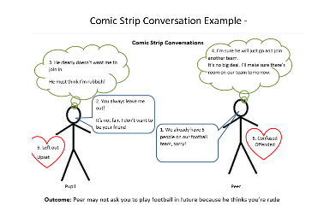  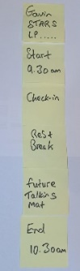  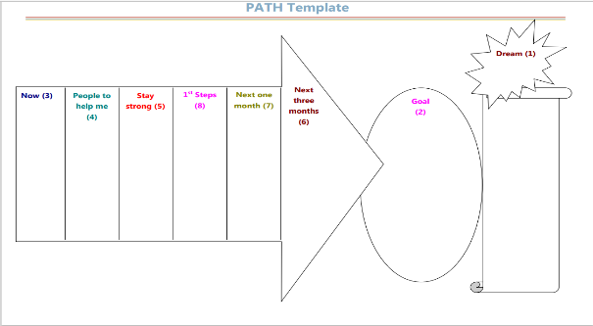  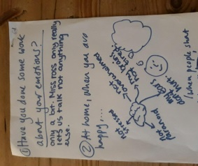  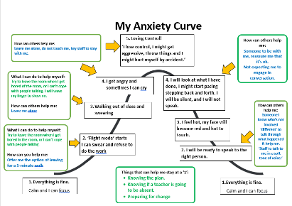

Resources and Links
STARS Introduction to Visual Supports
Path: path.pdf (kirkleeslocaloffer.org.uk)

See Third Party Disclaimer

