STARS introduction to gathering pupil voice
Introduction
What is pupil voice?
Pupil voice refers to the views, wishes and experiences of the child or young person (CYP) . It can give us information about their needs and wants, how they like to communicate, how they interact socially, and how they experience connection and belonging. It is an essential part of the assess and review phases of the graduated approach and should inform provision alongside parent and carer views.

Why is it important to gain pupil voice regarding school life?
CYP need to be given meaningful opportunities to share their experiences, views and hopes about school. They need to know that it is safe for them to express their views and that what they say is valued and will be listened to and feed into planning their support.

Based on Article 12 of The United Nations Convention on the Rights of the Child (UNCRC)





Resources, Links and References
Voice of the child or young person | Leeds for Learning
STARS Introduction to Observation
STARS Introduction to Mentoring
Talking Mats | Improving communication, improving lives
Lundy, Laura. (2007) ‘“Voice” is Not Enough: Conceptualising Article 12 of the United Nations Convention on the Rights of the Child’, British Educational Research Journal (33).
Strategies
Autistic CYP may require additional support and bespoke strategies to enable them to share their voice. Differences in autistic CYP’s social communication may impact on their ability to seek help or speak up, especially if they are experiencing high levels of anxiety. The following strategies may help autistic CYP to self-advocate, express their views, wishes and experiences, and communicate their needs to staff to support their wellbeing.
These strategies can be differentiated according to age, developmental level and interests.

Pupil voice can be gained via: mentoring sessions; structured pupil voice activities with a trusted adult, ad-hoc ‘check ins’; and through interaction and observation (see STARS introduction to observation for further information).
Example mentoring strategies & structured pupil voice activities
Use of a visual timetable to structure sessions and support self-advocation. For example:

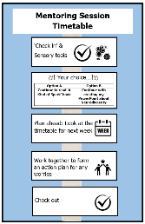


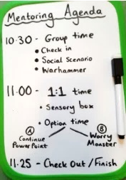

- Use of person-centred tools to support the CYP to share their voice openly and comfortably. For example, ensuring that the ‘top scale’ and option cards on a ‘Talking Mat’ are appropriate for, and make sense to, the CYP:
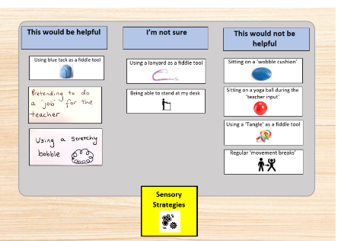
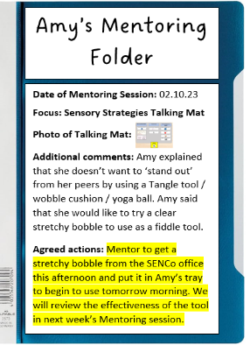
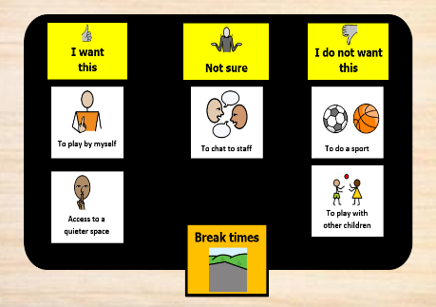

Ensuring that pupil voice informs the graduated approach and future provision. For example, agreeing and recording ‘next steps’ visually for the CYP and staff.

Example Check-in Strategies
Structured ‘check in’ sessions utilising visual systems which support the CYP to recognise and respond to different emotional states (these can be linked to their interests):
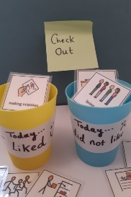
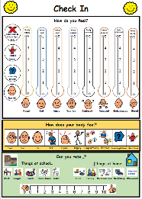
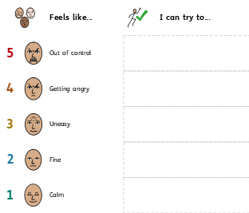

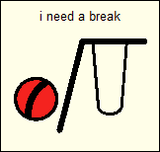
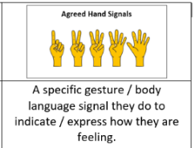
Use of an agreed signal to support the CYP to
express a need or emotional state to staff. For example

See third Party declaimer

