STARS Introduction to building a Sensory Profile

Introduction

What is a sensory processing?
Sensory processing is one of the 3 key areas of difference. Most autistic children and young people (CYP) will have differences in the way that they process and respond to sensory information. Sensory differences can impact significantly on play and learning and how an individual feels, thinks, behaves, or responds to the environment. This may result in barriers to learning and engagement. It is important that staff identify the sensory profile of a CYP as a starting point to meeting their needs and to inform how they adapt their teaching and communication style, the environment, and expectations in recognition of this.

Sensory profile
Autistic CYP can be over-sensitive (hypersensitive) to certain sensory information and under-sensitive (hyposensitive) to others.

It is important to carefully assess the individual needs of a CYP and pro-actively plan strategies throughout the day in response to their individual sensory profile. This will support their sensory regulation. For example, if a CYP’s sensory needs are running, climbing, throwing, and proprioceptive needs for pressure and touch, you may plan a sensory circuit or movement break during or after a period of focused work.
Pupil Voice
Gathering pupil voice and supporting CYP to understand their sensory needs is key.

This can be obtained through:
- Observations and interactions
- Completing a sensory checklist
- Pupil voice activity
- Drawing and talking
- Environmental audits
- Implementing a collaborative approach, where possible, with the child or young person and their parents/carers when planning support, e.g. parents/carers to complete a checklist at home and shared with the setting.

A CYP’s sensory needs can fluctuate daily and change over time. They may present differently depending on internal and external factors such as: the environment; their physical state (tired, hungry, stressed); their tolerance levels and daily experiences. In recognition of this, sensory profiles should be annotated and reviewed regularly.
It may be appropriate to seek further advice around sensory differences from your local Occupational Therapy team: LCH Occupational Therapy (ICAN) (leedscommunityhealthcare.nhs.uk)

Strategies

Sensory checklist
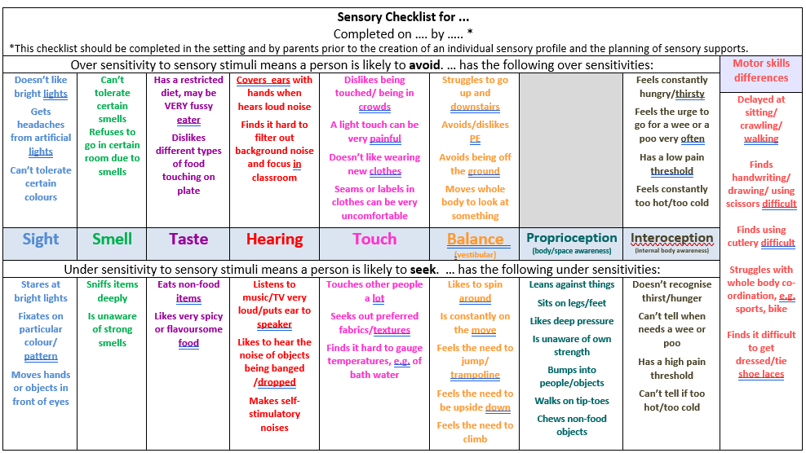
Highlight any of the statements on the checklist that apply to the child or young person.

This should be completed by staff in the setting, parents/carers, and the CYP (where appropriate).
Examples of sensory profiles/plans

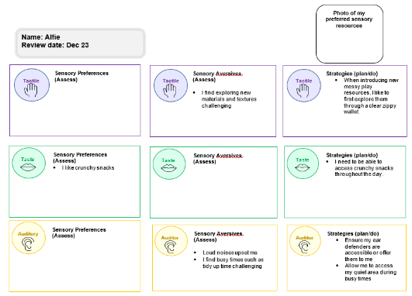

Resources and Links
STARS Introduction to Pupil Voice
STARS Introduction to Observation
Joining in with Sensory Differences | NHS GGC
EY SENIT Sensory Toolkit

See Third Party Disclaimer

