
Sensory Stories
Autistic children have differences in the way they process sensory information. They may be Sensory Seekers and seek more input from their environment or Sensory Avoiders becoming overwhelmed by things around them. Sometimes a child’s responses may be a combination of these dependent on their level of arousal or their resilience and ability to self- regulate at that time or on that particular day. Before introducing Sensory Stories to an autistic child please make sure you know their sensory needs and preferences, have completed a sensory checklist and profile so you are aware of the individual child’s sensitivities.

Top Tips for Creating a Sensory Story
- Choose a story or theme and make it fun
- Summarise it into short sentences keep it short and simple (10 to 15 sentences if possible)
- Pick 10 Key words usually the who, what, where, and action words
- Identify props to represent the Key Words
- Make some noise. Incorporate claps, musical instruments, and noises to encourage the child to join in.
- Use your imagination – for example, rain could be reflected with pattering fingers or a garden water spray
- Your characters should speak to bring them to life, use repeated refrains and key words to reduce information processing demands and support recall.
- Each sentence you retell should have a sensory experience
- Include a range of sensory experiences to maintain interest and attention for example, sound, speech, instruments, tactile experiences
- Repeat, repeat and repeat again to support learning and engagement

Types of multi- sensory story books
- Children’s story books incorporating visuals, tactile patterns and sound.
These are readily available for example, the ’touch and feel’ That’s not my… range of books.
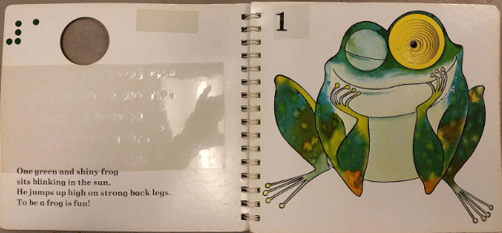
- Standard story books enhanced with sensory props to convey story sensations.
- Simple stories devised by practitioners around children’s interests presented primarily in sensory ways
Examples of these below

Creating a Touch and Feel Tactile Book Top Tips
Focus on Real Life Experiences and if possible, link into the child’s recent experiences
- Present meaningful information linked to the child’s interests and use visuals that the child will easily recognise
- Make the tactile pictures clear and uncluttered with spaces between different elements
- Use a range of textures in the story and use them consistently throughout the book
- Use simple shapes and secure firmly
- Emphasise significant details (for example, the sharp teeth of a wolf or the soft coat of the bear)
- When reading the story use sound effects or different voices for the characters
- Collect some objects that appear in the story for the child to hold and explore while you read

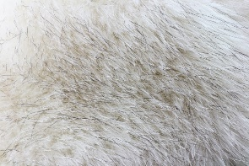 An example of fabric replicating an animal ‘s fur in a story 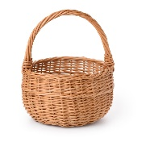Consider presenting the story with props in a story basket

Presenting a Multi- Sensory Story with a group of children
- Work with a small group of children at a time
- Use the guide above to develop your story and choose the sensory props you wish to use
- 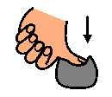Allow time for each child to handle the object or experience the sensation before moving on
- Repeat the sentence for each child as they handle the object
- Acknowledge each child’s response
- Be aware of individual children’s sensory likes and dislikes
- Remember to ask yourself does this meet the sensory needs of the children in the setting to make the experience engaging (for example, those with sight or hearing impairments, can we make the items bigger to support this?)

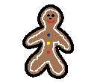
Example of a Sensory Story

The Gingerbread Man
Story | Activity | Resources | Keywords
One Day an old lady made a gingerbread man | Encourage children to squash and squeeze the dough | Ginger scented playdough | made
When it was cooking, she heard a knock at the oven door | Knock 3 times using a wooden clave or tapping beaters | Wooden cleaver and beater | knock
She opened the door and the Gingerbread man jumped out of the oven. | Introduce Gingerbread man puppet passing it around the group. | Gingerbread man puppet | Gingerbread man
He sang, “Run, run as fast as you can, you can’t catch me I’m the Gingerbread man” and ran away. | Use Gingerbread man puppet acting out him running away encourage the children to tap their feet on the floor to make a running sound and introduce the refrain. |  | run
The old lady ran after the warm Gingerbread man shouting “you look good enough to eat, Stop come back” | Pass round warm wheat bag to feel. | Warmed scented wheat bag | warm
The Gingerbread man met a hungry cow “Stop you look good enough to eat!” the cow said | Make a Moo sound and pass round the furry material. Then  Encourage the children to act out the Stop sign. | Soft furry material | cow
The Gingerbread man kept running singing “Run run as fast as you can, you can’t catch me I’m the Gingerbread man” | Encourage the children to tap their feet on the floor to make a running sound as they repeat the refrain |  | run
The old lady and the cow ran after him. | Act out the lady and cow running | Lady and Cow stick puppets | ran
The Gingerbread man met a hungry horse “Stop you look good enough to eat!” the horse said | Make a neigh sound feel the rough material Then  Encourage the children to act out the Stop sign. | Rough material | horse
The Gingerbread man kept running singing “Run, run as fast as you can, you can’t catch me I’m a Gingerbread man” | Encourage the children to tap their feet on the floor to make a running sound as they repeat the refrain |  | run
The old lady, the cow and the horse ran after him. | Act out the lady, the cow and horse running | Puppets of lady, cow and horse | ran
The Gingerbread man came to a river. He could not get across. | Pass round and then shake out and place blue material on the ground to represent the river | Large piece of blue material | river
A fox appeared.  “I can take you across the river if you hop onto my back he said” | Pass round the fox puppet and furry tail material | Fox puppet and soft furry tail material | fox
The gingerbread man hopped onto the Fox’s back, and they jumped into the river. | Use a half full water bottle to make splash noise.  Encourage the children to hop and then jump. | Half full litre bottle of water | Hop and jump
The Fox said ” you are getting, wet hop onto my nose” | Spray children with water | Water spray | wet
The gingerbread man hopped onto the fox’s nose. | Use puppets to act out actions and encourage the children to hop. | Gingerbread man and fox puppets | hop
The fox flicked up his nose opened his mouth and ate up the gingerbread man. | Hand round ginger biscuits and encourage the children eat the biscuit | Ginger biscuits | ate
The Gingerbread man had all gone and the fox had a full tummy. | Rub tummy |  | tummy

An example of an interactive Sensory Story Time Session
