STARS introduction to

‘Flipping Your Lid’ The Loss of Rational Thought and Control

Introduction
The "flipping your lid" metaphor and the accompanying Hand Model of the Brain were created by Dr. Dan Siegel, a renowned clinical professor of psychiatry at the UCLA School of Medicine and an expert in neurobiology and mindfulness. These concepts are helpful when explaining the brain's reaction when emotions become overwhelming, leading to temporary loss of rational thought and self-regulation. When an individual experiences intense emotions such as anger, fear, or anxiety, their brain undergoes a significant shift. This shift leads to a loss of access to the prefrontal cortex – the rational part of the brain responsible for memory, decision-making, impulse control, and self-regulation. Instead, the person reverts to instinctual responses governed by the emotional brain, particularly the amygdala. Neurodivergent children and young people tend to spend more of their time in an anxious state and are therefore more likely to ‘flip their lid’. Their ‘stress pots’ can fill up faster due to differences in their sensory, social communication and information processing needs.

The model of the brain
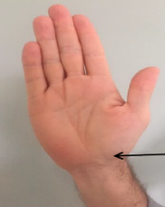  Imagine that your hand is the brain and from your wrist down is your spinal cord |  | 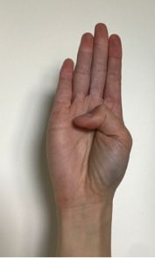  The thumb across the palm of your hand represents your  Emotional brain (limbic) |   Bend your fingers over the thumb. Your fingers are your thinking brain (cortex). The fingernails are the pre-frontal cortex.
Flipping the Lid | What is happening? |  |  | What might you see?
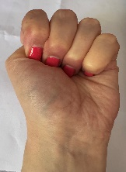  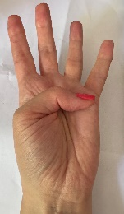  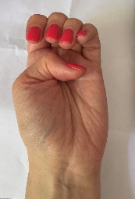 | This part of the brain is responsible for thinking, reasoning, and flexibility. It also helps regulate the activity of the lower parts of the brain (the brain stem and limbic system), allowing us to consider our actions before proceeding. |  |  | Your logical brain is functioning, and you have control over your emotional and physical responses.
 | As the hand opens, you may experience a decrease in control over your emotional and physical responses. This can result in increased adrenaline production, as well as elevated breathing and heartbeat. |  |  | This stage is often characterized by intense emotions presenting as shouting, swearing, crying, or throwing objects. Some individuals may become non-verbal during this stage.
 | When the cortex (represented by the fingers) loses control, the hand fully opens, indicating a state referred to as 'flipping your lid'.  The base of the hand (representing the brain stem) and the thumb (representing the limbic system) collaborate to regulate arousal levels, such as wakefulness, alertness, and emotions. They are also responsible for managing the response to perceived threats, known as the Fawn, Flight, Fight, or Freeze response. |  |  | In this state, individuals may act impulsively, exhibit rigidity, and be unable to respond to reasoning or instructions. Cognitive processing capabilities are significantly diminished. The fight, flight, freeze, fawn response will be observed.
Various stress factors can lead to a person losing control, such as environmental stimuli, social interactions, differences in sensory processing, and traumatic experiences. These stresses accumulate uniquely for each individual. Remember, this is a biological response beyond the child's control, not a choice. Behaviour is an adaptation to the environment, and our responses will be influenced by our previous experiences- a child who has had to be alert to shouting and run from harm, may still run when they hear raised voices, even if there is no actual risk of danger to them in that situation. It is a survival instinct.

Strategies
- Knowing your child is key
- Gain pupil voice through observation, pupil voice mats, conversations and other activities
- Support self-awareness. Does the CYP have differences in their interoceptive sense? Support them to build this and recognise how sensations in their body can relate to their emotions
- Support emotional regulation. Explore with them what helps to calm them when recognising they are becoming emotional
- Support them to meet their sensory needs. Use a sensory checklist, build a sensory profile and encourage regular and scheduled movement / sensory regulation breaks. Provide a way for them to ask for this if / when they recognise they need it
- Reduce demands. Consider the level of demand of each of the three areas of difference on our pupils and remember that demands are not just things we ask them to do; consider how sensory, information processing, communicative and social demands have an impact on them.
- Increase their level of control. Give them choices, autonomy and opportunity to advocate. Ensure you act upon what they tell you they need if they are able to
- Carry out check-ins at key points of the day e.g. arrival to school, break time etc. This gives the opportunity for you/ them to recognise where they are at in terms of regulation and encourage some regulatory activities if necessary

- Create a neurodiversity-friendly, low-arousal environment. Again, consider the three key areas of difference when doing this
- Use co-regulation strategies e.g. a toolkit for regulation, safe spaces, break cards etc. and ensure staff understand how to support co-regulation for the young people they work with
- Give time. It can take a long time for a child to recover from ‘flipping their lid’. You need to know the child well and be able to recognise when they are fully regulated before any new demand / expectation is presented to them. Remember that even activities the child enjoys can be too much if they are still dysregulated.

Resources and Links
Dan Seigal Hand Brain Model Explained
MindMate Stress Pot
STARS Introduction to Pupil Voice
STARS Introduction to Observation
Make tasks less demanding
Co-regulation strategies
Guide to making a calming tool kit
Example Book of Calming Strategies
Kelly Mahler supporting interoception
An Introduction to meeting sensory needs
STARS Bite sized clips for parents/carers
Training
STARS Training-Bespoke
See third party disclaimer

