Create a Calming Toolkit

Please ensure that all sensory resources are suitable and safe for the young person to access.
Examples:  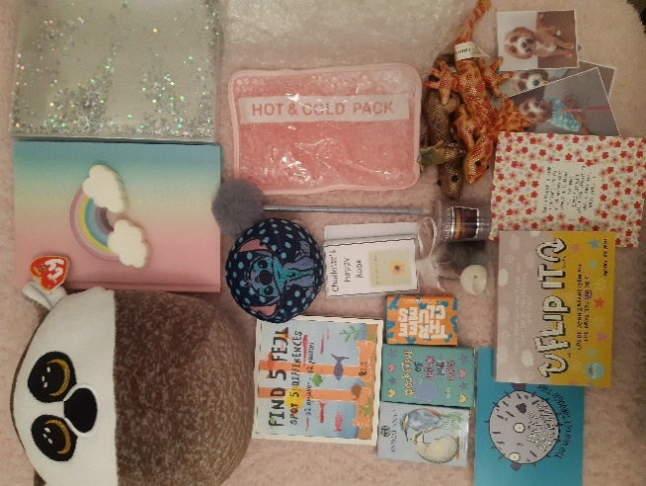  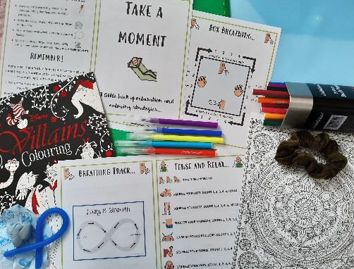  It is important in constructing your Calming Toolkit that you include items that are personally relevant to you and that it is easily accessible. You can always add to your kit or remove items that are no longer helpful. | Ideas of things to include:  Touch:  - Stress ball  - Playdough, blue-tac, slime, putty  - Stuffed toy or squishy  - Piece of material or clothing which has a comforting texture for you  - Sensory notepads and stationery  Smell:  - Scented candle or oil to smell  - Scented rubbers, pen and stationery  - Piece of fabric or a scrunchie with your favourite fragrance  Taste:  - Favourite food or treat  - Flavoured water drops to make a comforting drink  Hearing:  - Favourite CD  - ‘Talking Postcard’ message from a loved one  - CD of relaxing music such as waves crashing or rainfall  - Talking book or mindfulness podcast  Sight:  - Colouring, pens and paper  - Puzzle or activity e.g., spot the difference, ‘Where’s Wally’?  - Photos of friends, family, pets or a place with happy or calm memories  Positive affirmations:  - You could include positive affirmations or kind words from a friend, family member or teacher. You could create a ‘celebration scrapbook’ which includes photocopies of your certificates, achievements and positive feedback from others.  - You could write a letter to yourself and keep it in your calming toolkit to inspire or comfort you.  Grounding techniques and mindfulness activities:  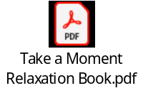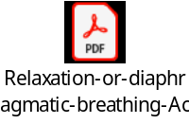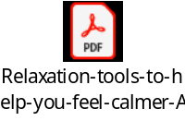

Purpose
- Calming Toolkits can help in times of stress or distress when it is difficult to think rationally
- They can help with emotional regulation and can support individuals in developing resilience to stressful situations.
- By using tangible objects to distract and self sooth the objects can give a sense of immediate comfort and offer an alternative to angry personal exchanges or potentially self-destructive behaviours.

