Choosing Boards
A choose board is a visual strategy, used to support children in making choices; often when it is not visually apparent what is available to choose from e.g., what to eat for dinner or what/where they would like to play. It is particularly helpful for children who are unable to scan a room/area and select an activity during undirected free time.
A choose board may be particularly helpful for children who are unable to recall from memory what may be on offer.
Before introducing the element of choice, you initially need to work on ensuring that your child understands the relevance of a symbol/photograph.
A Choose board is a laminated piece of card with spaces for 5 to 6 symbols to be Velcroed on it (each space does not need to be filled). These symbols will be the choices on offer, ensure that each activity is available at the time of offering.
Avoid placing the symbols in a line as it may confuse the child into thinking that the activities need to be accessed in an order.
The child should be encouraged to look at the board and select an activity that they would like to do. The adult may need to support them by pointing to each card and naming the activity.
The choice of ‘activities’ should initially focus on the child’s interests/likes; however this can be extended to include new areas of provision/toys etc.
Once the child has made the selection, they should take the visual symbol to the chosen area and place it on to the baseboard. The adult may need to support them to travel to the chosen area and then participate in play.
Over time the level of adult support can be reduced, needing only verbal prompting to look to their board and select an activity.
A choose board can be used in conjunction with a visual timetable or now and next board by placing a Choose Symbol on to the timetable or board
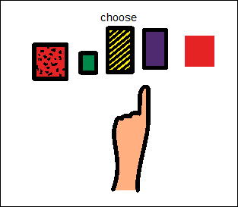
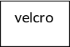

velcro

