Name:_________________________ Long Date:______________________________
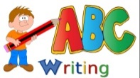

ADJECTIVES

I can use capital letters for names of people, places, day of the week, months of the year and personal pronoun I

I can join two sentences using ‘and’

I can use expanded noun phrases

The Lion the Witch and the Wardrobe

Word Bank:

Word Bank:
Key words scribed with/by adult about the picture. E.g. coat, bag etc...
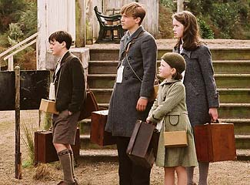

were
children
it’s
there
went

