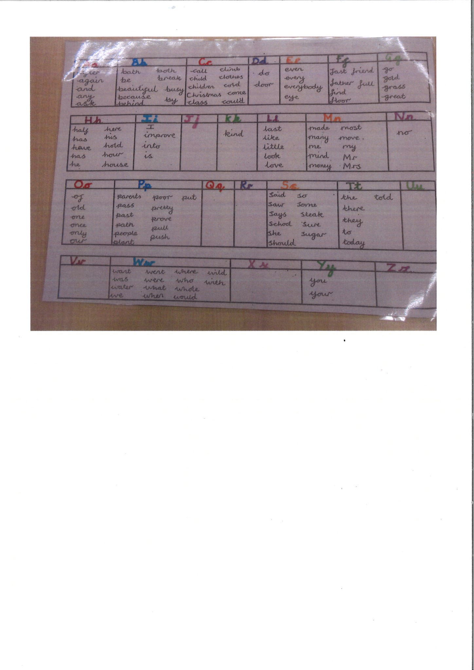

Personalised alphabetic Word Mat

