Cloze Procedure

With key words

One _______ morning.  A _________ lollipop lady stood  in the ____________ road. | 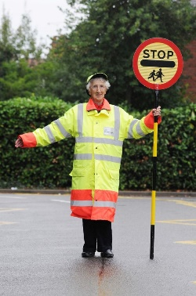

Keywords
sunny
friendly
busy

Without key words
One ______ day, a ________ girl, went to the ________ bowling alley with her friends. She picked up a _____ ball. This should bring me ______ she hoped. | 