IAT introduction to intensive interaction

Introduction

What is Intensive Interaction?
Intensive Interaction is a socially responsive approach designed to support children and young people (CYP) who are at the early stages of communication. It was developed by Dave Hewett and Melanie Nind in the late 1980s. It aims to teach the fundamentals of communication, social knowledge, and support emotional wellbeing.
Fundamentals of Communication

Why does it work?
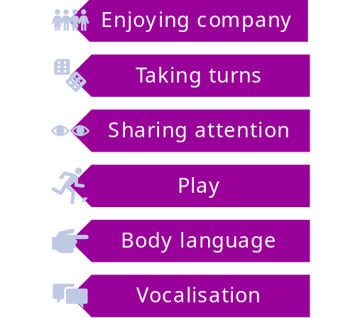
Through intensive interaction, the child has opportunities to develop and practice:
- Sharing personal space
- Tolerating and learning to enjoy the company of others
- Attending to others
- Learning to play and have fun
- Concentrating and increasing attention span
- Learning to complete activities in sequence
- Using and understanding facial expressions and other non-verbal communications
- Using and understanding vocalisations which may gradually become more precise and meaningful.

Strategies
Intensive interaction should be used throughout the day as an approach to building positive and trusting relationships with the CYP and should inform your approach to communication and interaction with them.

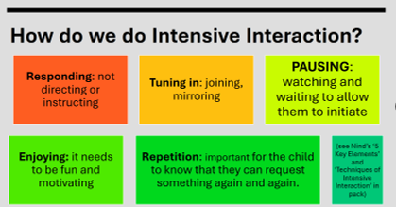

Top tips
- Intensive interaction is a person-centred approach, so it is important to get to know the CYP that you will be working with
- Some CYPO may benefit from additional 1:1 sessions in a quiet low arousal area free from distractions to help them to focus on engagement with the adult.
- The adult should always be responsive to the child and be as predictable as possible in their interactions
- Always be led by the child.

During sessions
- Begin by joining the child and tuning in to what they are doing.
- Get on their level mirroring their actions and vocalisations.
- Show interest in their activity, using open body language and a positive facial expression.
- Follow the child’s lead and provide opportunities to share personal space, attention and actions.
- Provide opportunities (pause) for the child or young person to take their turn in the communication.
- Watch for indications that they would like the interaction to continue, be repeated, altered or finished.
- Ensure there are lots of opportunities to repeat the interaction when requested by the CYP.
- Be aware that some CYP may withdraw from interaction for a short period of time to process before returning to the adult to re-engage.
- Watch for ‘green light’ moments when a CYP may be initiating interaction or communication that they are ready to re-engage.
- As the child becomes more comfortable with an interaction, look for opportunities to extend their play: for instance, modelling interactive play or simple turn taking in vocalisation or action.

Resources and Links
Further information and training can be found here: Intensive Interaction Institute
Bryony Rust (SaLT): What is Intensive Interaction?
Interview with Dave Hewett: Intensive Interaction: So... what is Intensive Interaction?
Autism - how does Intensive Interaction help people with autism?
Tom: 'The Intensive interaction Handbook'

Training
The STARS team deliver an Introduction to Intensive Interaction training, bookable via Leeds for Learning: see guidance on how to book bespoke training.
See third party disclaimer

