Example Structured Phonics Session - Example Lesson Plan – 20-26 mins (min. 3 x per week)
- Follow a structured, cumulative approach (e.g. Letters and Sounds/ Ruth Miskin / Jolly Phonics etc.)
- Ensure Pure Sounds are used throughout. Always maintain structured delivery and pace.
- Try to not work on more than 4-6 sounds/graphemes at a time. Do not introduce new graphemes/sounds until some have reached consolidation. Continue with multi-sensory overlearning and games in order to achieve this.
- Adjust the programme to appeal to pupil interests and needs, where possible.

Time | Item | Comments
3 mins | Automaticity or Phonological Awareness work (dependent on needs)  For example Alphabet Arc (online training available at https://www.leedsforlearning.co.uk/Event/128900 or  Phonological Awareness Pack
3 - 4 mins | Review (overlearning, check consolidation)  Previous graphemes / words / spellings - games-based/multi-sensory (see below)
3 - 4 mins | New GPC Discovery Learning (pupil listens or looks at list to identify the ‘grapheme’ being worked on – staff do not ‘tell them’)  - Pupil to identify/highlight the grapheme  - Multi-sensory learning of grapheme (see below)  - Flash cards – add new grapheme to known graphemes and flash through (can time to add a ‘competition’ element – can you get faster?)  - N.B – If no new GPC introduced in session – extend Review section
2 mins | New Words for Reading  - Pupil reads list of words with focus grapheme.  - Focus on use of pure sounds and use a ‘talking postcard’ to support blending, if required.
2-3  mins | Read words within phrases/sentences  Pupil reads phrases/ sentences with new grapheme words and other known words.
3-4  mins | Multi-sensory Word Spelling  Use of multi-sensory activities to learn spelling of words containing new grapheme e.g 4 Step etc. (see below for activities)  Short Phrase Dictation of known words  Pupil writes/types a short phrase/sentence using new grapheme word plus known words. Use multi-sensory techniques to support retention of phrase before expecting pupil to write (see below ‘Multi-sensory Dictation’)
4 - 6 mins | Consolidation exercises  Games based and multi-sensory exercises of words with new and previous graphemes (see examples below)
Summary of progress/errors / next steps

Multisensory/games-based learning/consolidation

Activity Suggestions
- 4 Step Grapheme/ Whole Word Learning (see below)
- Magnetic Letters (e.g. how many words can you make in…?)
- Bingo (new and known) or Grapheme/Word Match or Snap (can use flashcards)
- Word sort (known and target graphemes/word)
- Draw grapheme on back with finger – which one is it?
- Take target grapheme/words and place randomly on speed reading grid. How many can you read in 30 seconds/1 minute? (see below)
- Board Game (example below) or any other activity that pupil enjoys)
- See link for multi-sensory spelling activity ideas - https://www.tes.com/teaching-resource/multisensory-spelling-strategy-flashcards-6022314


Speed Reading grid
How many in 30 secs/1 minute?
Repeat next session; can you beat your score?
4 Step – Copy onto A4 sheet
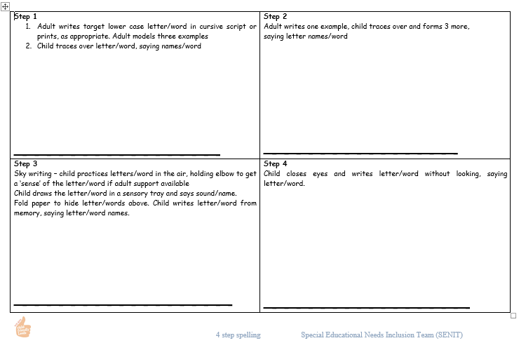

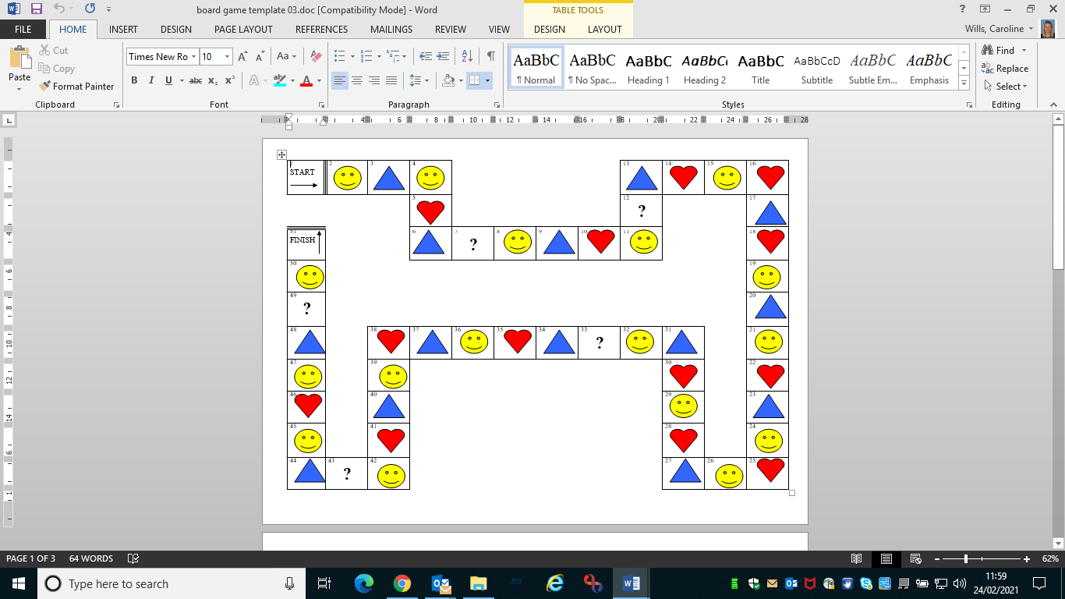

EXAMPLE BOARD GAME - Enlarge. Need counter, dice and timer. How quickly can you complete the board or compete against someone else – who finishes first?
Work from flash cards or word/grapheme list.
Face = roll again Triangle = Spell grapheme/word
Heart = read grapheme/word ? = choose read or spell

Multi-sensory Dictation
- Ensure dictation is suitable length for pupil (may only be 3-4 words for some), and only includes words they already know plus 1 new grapheme word.
- Say the phrase. As you say each word, touch a finger on your hand to represent it. Ask the pupil to join in with you saying and touching their own fingers. Repeat a minimum of 3 times.
- Check if the pupil can remember the phrase by taking turns with them to say the phrase and touch fingers (minimum of 3 times). Continue to say the phrase and touch your fingers but each time use a different voice e.g. quiet, loud, funny voice, stern voice, squeaky voice etc. Pupil to copy your voice on their turn.
- If they are struggling to recall the phrase, introduce a sign or movement for each word. This can be an official sign (Makaton/BSL), an initial letter cue (BSL) or one you have made up. Model 3 times for the pupils. Pupils to join in 3 times. Pupil to take turns with you 3 times.
- Ensure pupil can say phrase 3 times in a row without turn -taking/modelling before moving on.
- If required – include extra ‘small step’ modelling. Using a whiteboard and pen, ask the pupil to tell you the whole phrase. Then ask for the first word. Then ask them how to spell it. Only write it down when they have told you how to spell the word – one word at a time. You may want to do it incorrectly on occasion to check that they can see it needs changing. Continue the process until the whole phrase is written down. Ensure at the end that you ask if there is anything missing (e.g. to prompt them to tell you about a capital letter or full stop if they haven’t already done so). Read the phrase though together whilst pointing at the words you have written.
- Pupil to write or type the sentence (if they are physically able). Prompt pupils throughout to use the strategies they have learnt (e.g. repetition, use of fingers, use of signs/actions)

