Example Structured Small Step Phonics Session - Example Lesson Plan – 20-30 mins (min. 3 x per week)
- Follow a structured, synthetic phonics approach (e.g. can work with RWI Phonics and Word Time). Only 1 starred* section per session (A, B or C). If not consolidated, repeat that section again the following sessions until consolidated.
- Ensure Pure Sounds are used throughout. Maintain structured delivery and pace (move through the activities using the suggested timings – make a note if something needs to be covered again the next session). Using signs (e.g. Makaton) for letters and words, where possible, can support memory.
- Do not introduce new graphemes/sounds until the group of graphemes (4-6) have reached consolidation. Continue with multi-sensory overlearning and games in order to achieve this.
Time | Item | Progress/Errors/Next steps
3-5 mins | Phonological Awareness Development activities  - See activities in Phonological Awareness Pack
3-5 mins | Review (overlearning, check consolidation)  - Previous graphemes / words / spellings - games-based (see below)
* Session A  10-14 mins | New GPC Learning (1 at a time, do not move on until some consolidation reached and all letters in group needed for words for reading and spelling)  - See, hear, say (modelled then pupil)  - Hear and overwrite (modelled then pupil, can be sensory (e.g. sand/foam)  - Match graphemes independently  - Hear sound, independently point at sound within other graphemes  - Pupil read sound independently  - If appropriate, pupil to trace/write/type each grapheme as they say it
*  Session B  10-14 mins | New Words for Reading (words containing covered graphemes, add symbols for meaning, if required (remove when appropriate))  - Model sounding out and blending. Point at each grapheme as you say it and slide finger under whole word to blend. Pupil copies/joins in.  - Model saying whole word, point at word. Pupil copies.  - Pupil matches words independently  - Staff sounds out word, pupil points at word from selection  - Staff reads whole word, pupil points out from selection  - Pupil sounds out and reads word, independently  - Pupil reads whole word (if possible), independently  - If appropriate, pupil to trace/copy/type word saying each letter as they write it, followed by saying the full word (spelling to be given to them)
*  Session C  10-14 mins | Spelling of New Words  - Model sounding out and blending. Point out each grapheme as you say it and slide under whole word to blend. Pupil copies process/joins in.  - Model sounding out and putting onto spelling fingers (see p.3). Pupil copies process/joins in.  - Put the word out of sight, model sounding out, spelling fingers then writing (or typing). Pupil copies process.  - Pupil independently sounds out, spelling fingers, writes/types. Encourage repetition of spelling fingers until pupil can remember sounds to write down (without looking at word).  - If time– additional multi-sensory learning of word (see below)
4-6 mins | Consolidation exercises  - Multi-sensory activities of letters or words (dependent on session coverage) containing new and previous graphemes (see egs below)
Multisensory/games-based learning/consolidation
Activity Suggestions
- 4 Step Grapheme/ Whole Word Learning (see below)
- Listen to/watch songs about the letter grapheme and match to correct letter from a selection
- Magnetic Letters (find the letter, make the word, timed for competition against self or peers)
- Bingo (new and known) or Grapheme/Word Match or Snap (can use flashcards)
- Word/Letter sort (known and target graphemes/word)
- Draw grapheme on back with finger – which one is it?
- Sensory letter/word formation (e.g. sand, foam, paint). Remember to say the letter as you are forming it.
- Take target grapheme/words and place randomly on speed reading grid. How many can you read in 30 seconds/1 minute? (see below)
- Board Game (example below) or any other activity that pupil enjoys. Also Letter School app (formation)
- Find letter in a bag. Pupil uses senses to find the letter you have said.
- See link for multi-sensory spelling activity ideas - https://www.tes.com/teaching-resource/multisensory-spelling-strategy-flashcards-6022314


Speed Reading grid
How many in 30 secs/1 minute?
Repeat next session; can you beat your score?

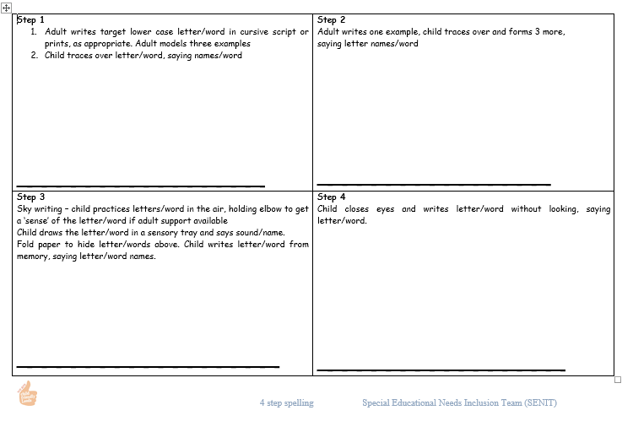
4 Step Multi-Sensory Grapheme/Spelling – Copy onto A4 sheet

EXAMPLE BOARD GAME - Enlarge. Need counter, dice and timer. How quickly can you complete the board or compete against someone else – who finishes first?
Work from flash cards or word/grapheme list.
Face = roll again Triangle = Spell grapheme/word
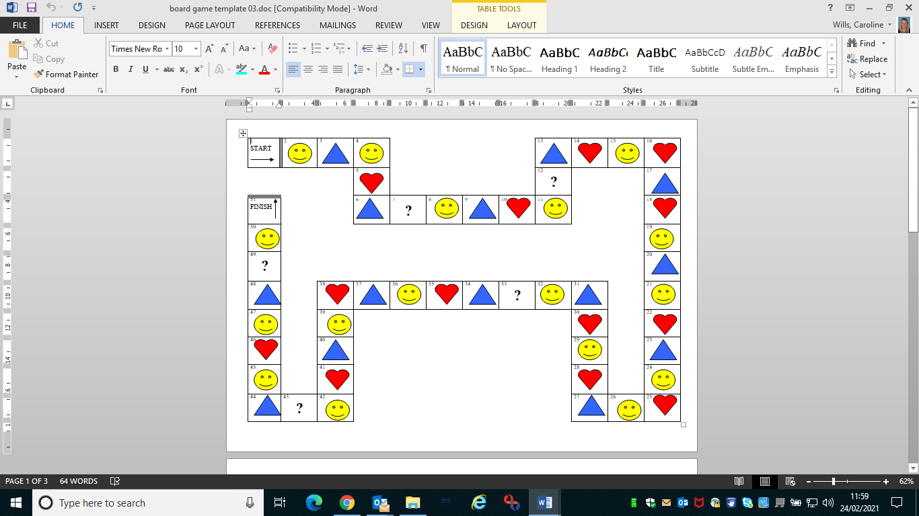
Heart = read grapheme/word ? = choose read or spell

Note – Spelling Fingers = hold your hand up, palm forwards, fingers spread. As you say each phoneme, touch a finger to represent it. At the end, move your pointing finger over the top of the spelling fingers in an arc and say the whole word (blending).

