Pupil Voice Pack
Listening and responding to the voice of children and young people (CYP) with SEND

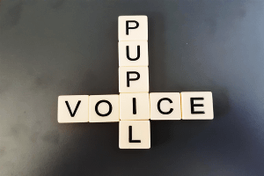

We listen, we learn, we change

This pack introduces the why and how of eliciting pupils’ views and asks practitioners to consider ‘what is the outcome?’ of pupil voice activities.
This pack provides an overview of several pupil voice activities designed to support practitioners in educational settings.


What is pupil voice?
- Pupil voice refers to the views, wishes and experiences of the child or young person (CYP).
- Within settings, pupil voice often refers to the participation, contribution and influence students have over their educational journey.
- Remember- 'Voice' doesn't mean speech; communicative behaviour may be a CYP's loudest 'voice'.

Why is it important?
- The voice of CYP is enshrined in law; SEND Code of Practice 2015, United Nations Convention on the Rights of the Child. See appendix 1 (page 19).
- Seeking, listening to and responding to the voice of the child is essential to safeguarding and promoting the welfare of all children and young people. See appendix 1 (page 19).
- Seeking and acting upon pupil voice is best practice and is intrinsic to the graduated approach.



Guidance: Seeking and Acting Upon Pupil Voice
- There isn't just one way to gather pupil voice; the way we seek and support a CYP to share their views will be unique to the individual and their needs.
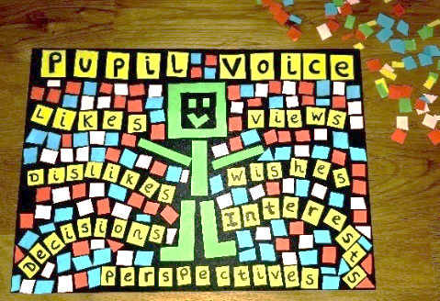
- Pupil voice activities should be meaningful, not tokenistic; pupil voice should be gathered over time and from various sources (everyday pupil voice opportunities are equally as important as more formal/planned pupil voice opportunities).
- Every piece of pupil voice helps build a constantly evolving picture of the CYP's views, wishes, and experiences (one piece of pupil voice is a snapshot in time).
- As we are gathering pupil voice, curiosity is key (remember- we are building an ever-changing picture of the CYP’s thoughts, feelings and wishes).
- Having a positive and trusting relationship with the CYP is fundamental to pupil voice; it is important that the CYP feels safe to express their views openly.
- Pupil voice work requires a setting-wide commitment to valuing, promoting and acting upon the views, wishes and experiences of all CYP (we might not be able to fulfil every CYPs’ wishes or make all the changes they want, but working collaboratively with CYP and their families is essential).
- Seeking and acting upon pupil voice is everyone's responsibility; all teachers are teachers of pupils with SEN and teachers should ensure that all CYP are involved in their learning in an enabling and inclusive environment.
- The universal offer in school is fundamental to ensuring the voice of the pupil is heard, responded to and valued. The most obvious evidence of pupil voice is though staff observations of the pupil’s presentation, and their engagement in learning and play with adults and peers- See page 4.
- Always be alert to pupil disclosing safeguarding information and ensure staff refer to their safeguarding procedures if this occurs.
- See appendix 2, (page 20) for potential risks when gaining pupil voice.

Pupil Voice: The Power of Observation

- Observation is a powerful method of gathering pupil voice in a person-centred way and is an essential part of the graduated approach. Even within pupil voice activities we are constantly observing and responding accordingly.
- It is important to ensure observations take place in a range of places, during different activities and over time.
- Observations may be formal or informal. A formal observation is usually planned, written up and has a clear purpose and objective. An informal observation is usually unplanned and ‘in the moment’ but may be recorded later. All observations are equally valuable.
- Observing involves noticing all forms of verbal and non-verbal communication. For example…
Passing or touching a picture/object
Gestures e.g. shaking their head
Changing their body position or facial expression

Pointing/hand movements/signing
Choosing/selecting something
Physical communication e.g. headbutts, pinches, kicking, tapping, throwing
Eye contact/ looking away/gazing
Standing near something/ someone
Using their own unique words for things
Changing the tone of their vocal sounds or speech
Crying/ laughing/ shrieking/screaming/singing
Making vocal sounds
Repeating sounds/words/ phrases
Vocal sounds becoming more urgent
Pulling, touching or guiding your hand
Observing/ looking towards something or someone
Moving/pushing away/leaving the area
Saying single words
Changing the volume of their vocal sounds or speech
Saying phrases or sentences
Drawings/text to speech technology/written words/symbol exchange
Babbling
Reaching towards or touching something

Guidance: Choosing Pupil Voice Activities
- Pupil voice activities are tools/approaches/resources which aim to support CYP to share their views, wishes and experiences. There is no one-size-fits-all.
- When selecting a pupil voice activity, it is important to ensure that it is person-centred, ensuring it is accessible and supportive for the individual. The examples in this pack (see page 7) offer some ideas that you may wish to adapt to the context of your setting as well as the needs of each individual CYP.
- Pupil voice activities can help elicit information on a range of topics, for example:
- Hopes fears, wishes and aspirations
- Feelings about school generally/attitude toward specific curriculum areas
- Awareness of their strengths and challenges
- Particular anxieties or concerns that are affecting wellbeing/learning
- Self-esteem
- Feelings about friends
- Strategies used to help
- What works/what needs to change
- What would be meaningful targets for that pupil
- Remember- Gathering pupil voice is not enough, it is what you do with the information that matters. Regularly seeking pupil voice should result in a tangible impact on their educational provision, for example:
- Adjusting provision at universal, targeted and personalised level to better meet needs
- Reviewing what is working and what is not
- Target setting for individual pupils
- Transition between Key Stages, year groups, schools etc
- Annual or mid-year SEND Reviews
- Sharing with parents
- Curiosity is key- One pupil voice activity is simply one snapshot in time; Consider- What other confirmatory evidence is there? Does this fit with what else we know? For example, from observation of the pupil, parent views, views of staff.
- Before using a pupil voice activity, use the ‘Key Considerations Checklist: Suitability of Pupil Voice Activities (see page 6).

Suitability of Pupil Voice Activities Reflection Checklist
- To consider before utilising pupil voice resources/activities:
 |  | Check
 | Is the resource/activity accessible to the individual child or young person (CYP)? Think- Sensory accommodations, SEN needs, SEMH, learning and cognition, communication preferences, environment, who is facilitating (Remember- relationships are fundamental), when, how long the resource/activity might take etc. | 
     | Is it meaningful to the CYP? What's the focus/purpose? Does the CYP understand the purpose? Is this topic important to/for the CYP? How is this going to help build the ever-changing picture of the CYP’s views, wishes, experiences? What insights are we hoping to gain?
 | Would this particular resource/activity facilitate and support the CYP to express their pupil voice? Does it help the CYP feel safe to express their pupil voice? Is it engaging and enjoyable for the CYP? Is it likely to strengthen relationships? Is it likely to build/maintain self-esteem; is it strengths-based and supportive? Would the CYP feel comfortable sharing views on this topic? Would the CYP feel comfortable to stop the activity or self-advocate they would like a break or support? What might promote their self-advocacy? How could we support them to feel comfortable and safe? What might we observe if the CYP becomes anxious/dysregulated? How should we respond?
 | How are we valuing the pupil voice gathered? How are we going to value the CYP's views and ensure that their views are integrated into the graduated approach? How are we going to communicate the value to the CYP? How would we respond 'in the moment' to requests that we are unable to action? (Remember- we might not be able to fulfil every CYP's wishes or make all the changes they want).
 | How are we going to act upon the pupil voice? How are we going to ensure that the CYP's views meaningfully shape the decisions that affect their lives? How are we going to communicate this to the CYP? How do we act upon potential safeguarding concerns? How would we respond 'in the moment' to potential views that cause concern or shock?

Example Pupil Voice Activities
    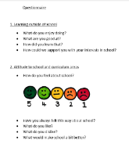  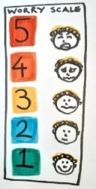  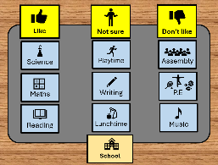    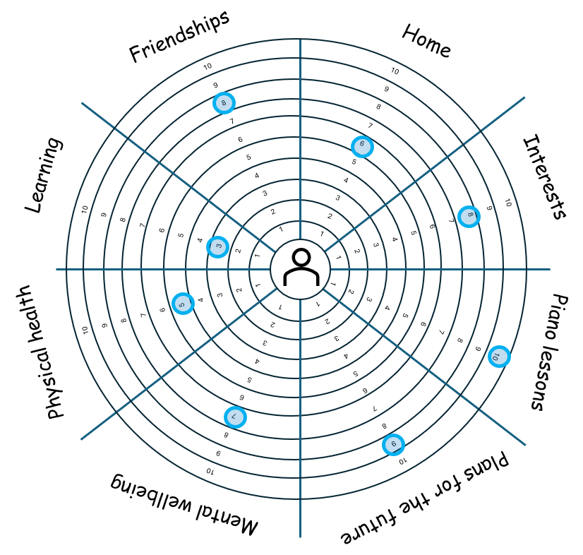  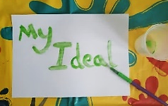  - ‘All About Me’ | See page 8
- ‘Getting to Know You’ Games | 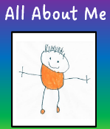  See page 9
- ‘Three Islands’ | See page 10
- ‘RAG-ing’ | See page 11
- ‘Pupil Voice Questionnaires’ | See page 12
- ‘Rating Scales’ | See page 13
- ‘Pupil Voice Mats’ | See pages 14-15
- ‘My Ideal School’ | See page 16
- ‘Well-being Wheel’ | See pages 17-18

These pupil voice activities are designed to:
- Build relationships – They help staff get to know pupils’ interests, strengths, challenges, and personalities beyond academics.
- Value pupil voice – They show CYP that their opinions, feelings, and experiences matter, fostering a sense of respect and belonging.
- Support inclusion – They allow CYP to share information in a way that feels comfortable, ensuring staff can adapt support accordingly.
- Promote self-awareness – Pupils reflect on their own identity, learning preferences, emotions, and goals, which supports personal and social development.
- Guide teaching and learning – Insights from these activities can inform lesson planning, classroom strategies, and differentiation to meet pupils’ needs more effectively.
- Encourage positive transitions – They provide continuity when pupils move to new classes or schools, as the information can be shared with the next teacher/setting.
Please note- This is not an exhaustive list of tools. It is essential that supporting adults check resources/content/approaches are appropriate and adapted for the individual CYP before utilising.

‘All About Me’

Pupil Voice Activity Overview
Purpose:  - ‘All About Me’ pupil voice activities aim to give CYP a structured opportunity to express who they are, how they learn, and what matters to them.  - ‘All About Me’ activities are a way of listening to pupils, celebrating individuality, and using their perspectives to shape a more supportive and personalised learning environment.  - ‘All About Me’ activities can facilitate relationship-building and can be especially valuable as part of the transition process. | 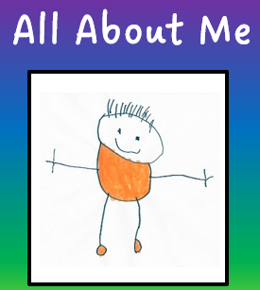

Resources:
- Sentence starters or questions presented in any format matching the pupil’s needs.
- Any IT or art materials to turn the activity into a creative or interactive project.

Guidance:
- Think about using sentence starters or questions to support with the ‘All About Me’ activity or project; adapt the activity to suit the individual and show curiosity. Remember— the information gathered from this activity is used to help create tailored support or plans based on the CYP's strengths, hopes, and goals, as part of the graduated approach.

Examples:
- All About Me Booklet – A simple booklet with prompts such as “My favourite subject…”, “Something I’m really good at…”, “Something I’d like help with…”
- Classroom Mapping- The CYP takes pictures or places post-it notes around the classroom or school to show their favorite areas/things.

- Learning Profile Sheet – Pupils complete questions like “I learn best when…”, and “Staff can try help me by…”
- Hopes and Goals Page – CYP set one personal and one learning goal for the term/year.
- My Learning Shield or Coat of Arms – Pupils design a shield with sections for strengths, hobbies, values, and challenges.
- Identity Collage – Using drawings or magazine cut-outs to represent themselves, their interests, and dreams.
- Two Stars and a Wish Discussion– Pupils are invited to say two things they like about school/learning and one wish they have for improvement.
- Class Jigsaw Puzzle – Each CYP decorates a puzzle piece with personal facts; pieces are joined to make a class puzzle.
- Who Am I? Game – Pupils write clues about themselves (e.g., favourite food, hobby, dream job) and classmates guess who it is.

‘Getting to Know You’ Games
Pupil Voice Activity Overview
Purpose:  - ‘Getting to know you’ games give CYP a chance to share their opinions and feelings in a fun and relaxed way, such as playing simple board games together.  - ‘Getting to know you’ activities are a way of listening to pupils, celebrating individuality, and using their perspectives to shape a more supportive and personalised learning environment.  - ‘Getting to know you’ games can facilitate relationship-building and can help pupils gain confidence in expressing themselves. | 
Resources:
- Prepared questions/prompts incorporated into a game e.g. board game.
Guidance:
- Ensure the game/activity is suitable and engaging for the CYP; be mindful about the number of questions and when to just play the game e.g. (pupil disengaging).
- Start by talking to the CYP about the purpose of this activity. It needs to be clear that this is a fun way of getting to know them and finding out the best ways of helping them to feel happy and safe in school.
- After the game, reflect with the CYP about what can be done to affect change for the better. Remember— the information gathered from this activity is used to help create tailored support or plans based on the CYP's strengths, hopes, and goals, as part of the graduated approach.
Examples:
- Pupil Voice Jenga: Write a question or prompt on each Jenga block (or number the blocks and have a matching question sheet). As pupils take out a block, they answer the question before stacking it on top e.g. ‘What’s something you’re proud of?’.
- Pupil Voice Snakes & Ladders: Use a standard Snakes & Ladders board or print a custom one. Each square has a pupil voice question or prompt. When pupils land on a square, they are invited to answer that question. Ladders = “positive boosters” (questions about hopes, strengths, and things they enjoy) e.g. “What helps you feel happy in class?” Snakes = “challenges” (questions about difficulties, worries, or things they’d like to change) e.g. “If you were the headteacher for a day, what’s one change you’d make?”.
- Would You Rather…? Corners Game: The adult asks fun “Would you rather” questions ('Would you rather have a pet dragon or a pet unicorn?”). Pupils move to a corner of the room based on their answer and discuss briefly with others in the same corner.
- Class Bingo: Pupils get a grid or list with prompts like “Find someone who has a pet,” “Find someone who likes drawing,” “Find someone who can speak another language.” They walk around asking each other questions to complete their sheet. This can help build peer connections, encourage questioning and listening skills, and help pupils discover shared interests.

‘Three Islands’
Pupil Voice Activity Overview
Purpose:  - ‘Three Islands’ is a variation of the ‘Three Houses’ activity and aims to gather pupil voice in a creative, low-pressure way.  - Three Islands can be adapted by professionals to discuss a pupil’s; likes/hobbies/strengths; dislikes/worries/challenges; and dreams/hopes/wishes.  - Three Islands can help gather pupil perspective in terms of positives, strengths and what pupils want to keep the same. The creative nature of the activity aims to provide pupils with a safe way to voice difficulties, concerns, or barriers and encourages suggestions for improvement. | 
Resources:
- Provide the CYP with a worksheet showing 3 islands (or ask them to draw their own) and provide pencils/pens/paint/modelling materials.
Guidance:
- CYP can either draw three islands on the pieces of paper or use a pre-made worksheet.
- Explain what each island represents and invite the CYP to draw/doodle/write on each island to express their pupil voice (see prompts below):
1. Island of Likes/Strengths: Example prompts- “What do you enjoy?”, “What’s going well?”, “What helps you learn or feel safe?”.
2. Island of Dislikes/Worries: Example prompts- “What don’t you enjoy?”, “What makes learning or school hard for you?”, “What do you worry about?”.
3. Island of Dreams/Wishes: Example prompts- “If you could design your perfect school, what would it look like?”, “What changes would make things better?”.
- Use ‘I wonder questions...’ to help explore the CYP’s views for example: “I wonder what made you put your cat on the Island of Likes…”.
- Be careful about interpreting what is drawn or shown too literally.
- After the activity, reflect with the CYP about what can be done to affect change for the better. Remember— the information gathered from this activity is used to help create tailored support or plans based on the CYP's strengths, hopes, and goals, as part of the graduated approach.
Examples:
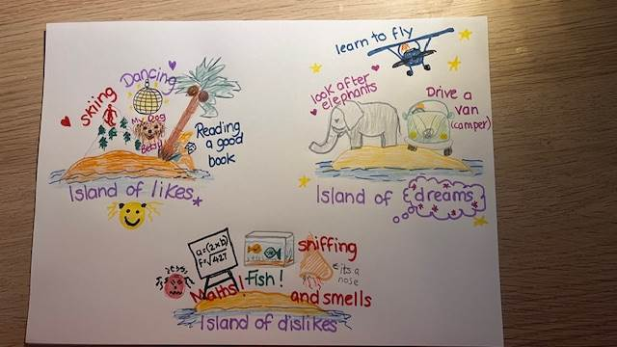
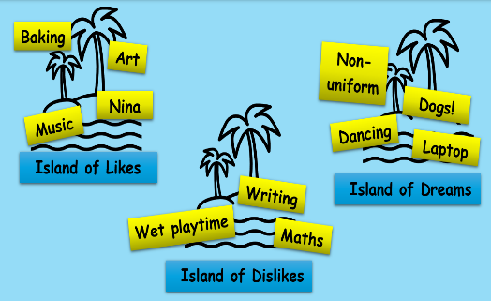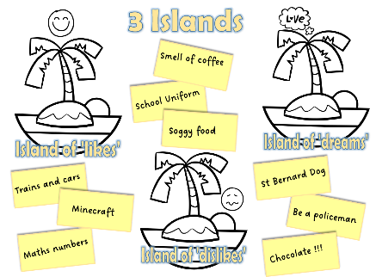

‘RAG-ing’
Pupil Voice Activity Overview
Purpose:  - ‘RAG-ing’ is a pupil voice activity where CYP reflect on their school experience using Red, Amber, Green (RAG) colours (or colours of their choosing) to identify and express their views.  - RAG-ing can provide a quick check-in/overview of pupil wellbeing and can help spot potential patterns.  - This tool gives CYP the opportunity to reflect on their school week/day and identify what they like/what is working well, and areas for improvement. | 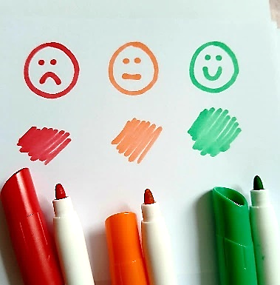
Resources:
- Provide the CYP with their timetable e.g., a printout, electronic copy.
- Provide materials for a rating system to be applied to the timetable e.g. coloured stickers, colouring pencils, highlighters, symbols/drawings, use of technology.
Guidance:
- Invite the CYP to rate how they feel about each lesson/part of their timetable using their colour-coding/rating system.
- Create a key that explains which colour corresponds to what e.g. (red = dislike, orange = ok, green = like).
- After colouring, pupils may wish to add a comment box or drawing explaining their colour/rating.
- Engage in a discussion via curious questions about ‘what works’, the aspects that would make school life ‘even better’ and explore what they and others around them could do to improve the situation. Remember— the information gathered from this activity is used to help create tailored support or plans based on the CYP's strengths, hopes, and goals, as part of the graduated approach.
Examples:
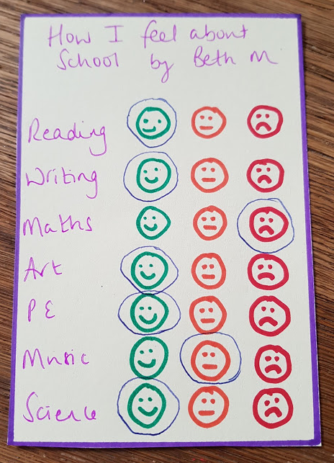
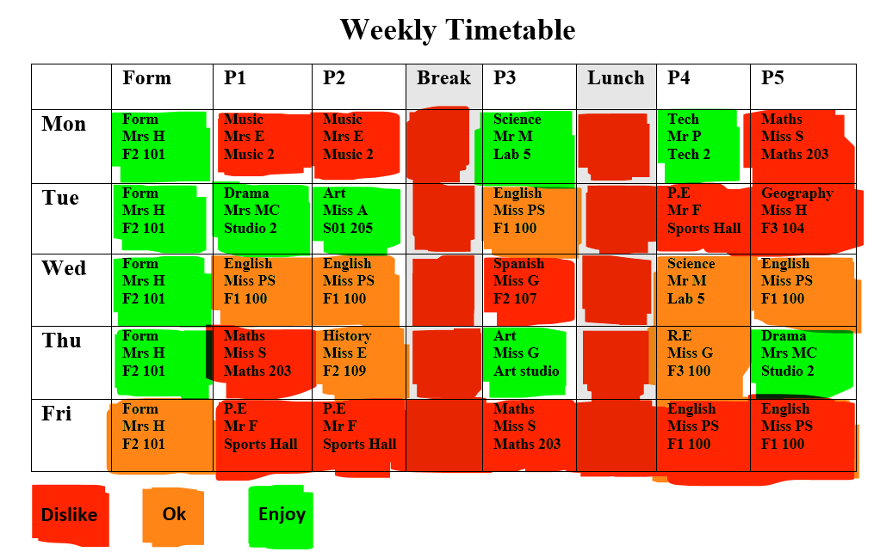

‘Pupil Voice Questionnaires'
Pupil Voice Activity Overview
Purpose:  - A pupil voice questionnaire is a tool used to gather feedback directly from students about their learning, wellbeing, and educational experience. They can cover areas like teaching quality, safety, inclusion, and how supported pupils feel.  - This tool gives CYP the opportunity to identify what they like/what is working well, and areas for improvement. |  |  |  | 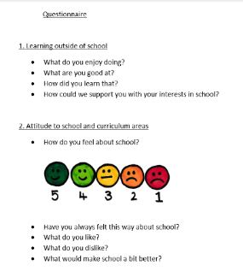
Resources:
- A bespoke questionnaire presented in a format that is suitable and accessible to the CYP.
Guidance:
- Be clear- Why are you gathering pupil voice? (e.g. learning, wellbeing, school improvement).
- Identify practicalities- Will it be online or paper-based? How will you reach all pupils (whole school, sample groups, pupil council)? Do pupils need adult support to complete it?
- Make sure the questionnaire is accessible to the CYP (e.g. dyslexia-friendly fonts, large print, audio versions, use of emojis, visuals, or symbols).
- Keep it short and focused- Too many topics/questions can overwhelm.
- Consider the types of questions to include:
- Closed questions (tick boxes, rating scales) for measurable data.
- Open questions for deeper insights.
- Avoid leading questions. Have options for ‘I am unsure’ or ‘I don’t know’.
- Use varied formats (tick boxes, smiley faces, short responses).
- Avoid overly complex or repetitive questions.
- Consider anonymity- Decide if responses will be anonymous.
- Ensure follow-up and impact- Plan how you’ll share results with pupils (e.g. assemblies, newsletters, “You said… we did…”). Remember— the information gathered should be used to help create tailored support or plans, as part of the graduated approach.
Example questions:
Learning & Teaching:  - What helps you learn best in class?  - How do teachers make learning interesting for you?  - Do you get enough help if you find work difficult? | Wellbeing & Safety:  - Do you feel safe at school/ college?  - Do you know who to talk to if you are worried?  - How do staff show they care about you? | Inclusion & Belonging:  - Do you feel listened to in school/ college?  - Are you treated fairly, no matter who you are?  - Do you feel proud to be part of this school/ college? | Environment:  - What do you like best about school/ college?  - What would you change to make it better?  - Is there a place where you can go if you need quiet time? |  | Pupil Voice & Participation:  - Do you get a chance to share your ideas and opinions?  - Are pupils involved in making decisions about the school/ college?  - What is one thing you’d like staff to know?

‘Rating Scales’
Pupil Voice Activity Overview
Purpose:  - Rating scales aim to support CYP to identify, communicate, and monitor their pupil voice in a structured way.  - The visual support is designed to help CYP spot the signs of emotional escalation and implement strategies to reduce the anxiety, anger or distress that has been triggered.  - This tool can support when ‘checking in’ with the pupil and can enable staff to identify times within the day that cause stress, anxiety, or heightened states of dysregulation. Changes or adaptations to the provision in place can then be made accordingly as part of the graduated approach. | 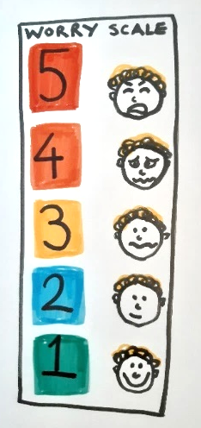
Resources:
- Materials to make a personalised visual support e.g., chart/scale template with visuals/photographs, art/crafts, use of technology.
Guidance:
- Work collaboratively with the CYP to design and create a personalised rating scale:
- Decide what the scale is going to measure/represent: General mood? Stress or anxiety? Energy levels? Different emotional states and regulation strategies?
- Choose the format and scale range e.g., numerical (1–5, 1–10), emoji/faces/visuals, colour-codes, zones/categories. The CYP may wish to base it on their interests for example, the visual stimulus could be related to dinosaurs, or their favourite TV characters.
- Design the visual layout and ensure it’s easy to complete (tick/circle/point to).
- Within different points in the day, using the visual stimulus, invite the CYP to indicate how they are feeling e.g. “Can you circle the face that shows how you feel right now?”, “Can you point to where you are on your scale?”. Reassure that all feelings are valid and that there are no right or wrong answers.
- Be curious- Support the CYP to express why they are feeling that way, and what could be done to help. Remember— the information gathered should be used to help create tailored support or plans, as part of the graduated approach.
Example rating scales:
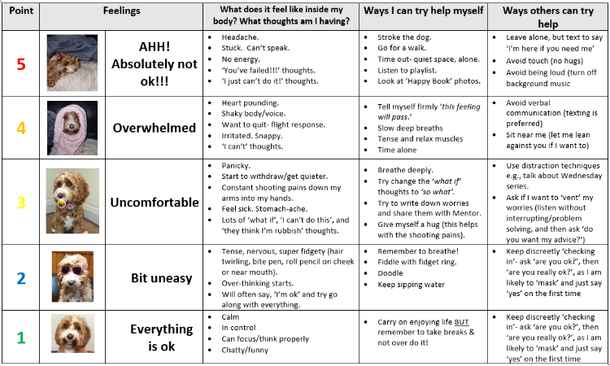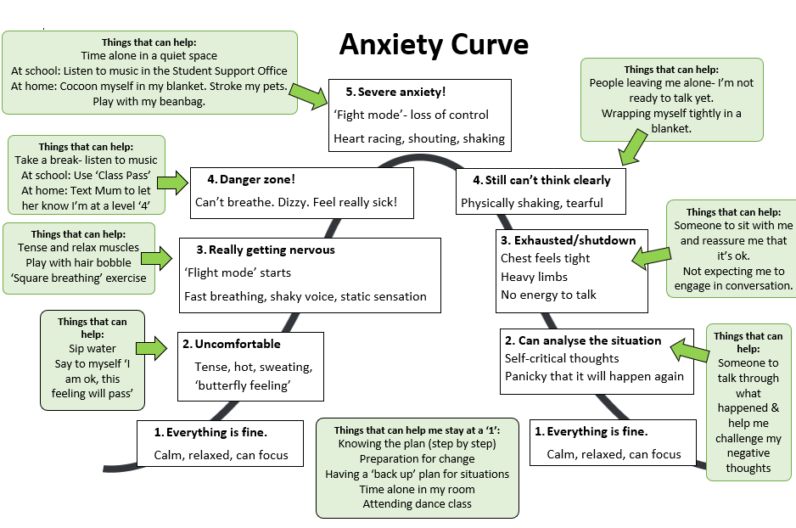

‘Pupil Voice Mats’*
Pupil Voice Activity Overview
Purpose:  - A ‘Pupil Voice Mat’ is a visual communication tool that can support individuals to share their thoughts, feelings and opinions, as part of the graduated approach.  - The Pupil Voice Mat approach aims to support individuals to process, reflect and make decisions via categorisation; the statement cards/symbols can support understanding by breaking topics down and giving the CYP processing time. | 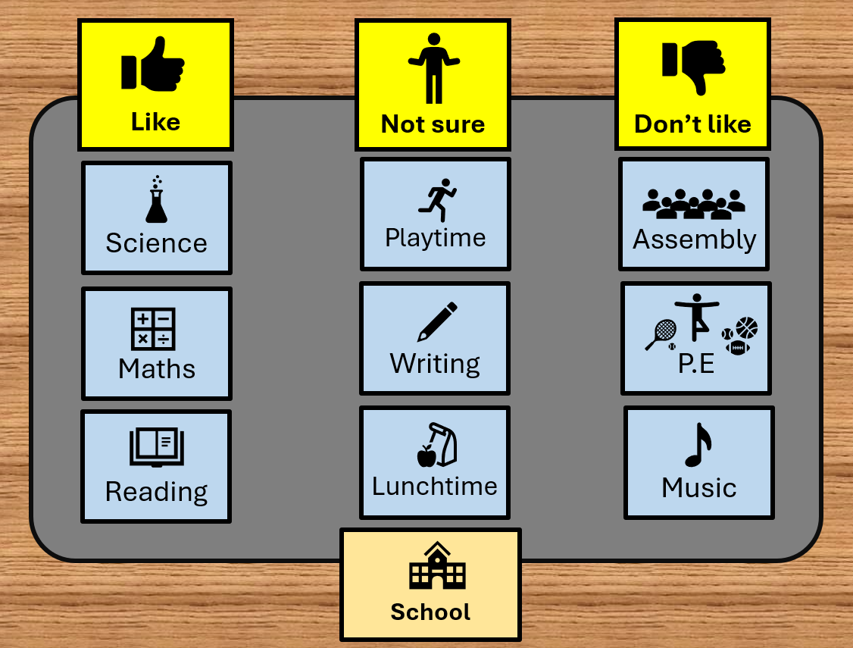
Resources:
- A physical mat (or use of technology), a topic to focus on, category headings (referred to as 'Top Scales') and statement cards, symbols or actual objects for the CYP to categorise on the mat, to express their thoughts/feelings/opinions.
- A set of blank statement cards/post-it notes for the CYP to add to their mat.
Guidance:
- The CYP does not need to speak/volunteer verbal information in order to access Pupil Voice Mats; however, they must understand the categorisation (they must have at least a two-word level of understanding). A helpful tip is to start with pupil voice activities using statements that you know the CYP enjoy. For example, if the CYP likes teddies, observe whether they place the teddy into the 'I Like' category on their mat, if not, then it is possible that the Pupil Voice Mat is not yet accessible.
- Step 1: Introduce the activity e.g. "We're going to do a Pupil Voice Mat. Here is your mat." (Place the mat in front of the CYP). Remember you can pause/stop/pass at any point."
- Step 2: Explain what the Pupil Voice Mat will be about e.g. "We’re going to do a Pupil Voice Mat to explore what you think about ___". (Show and place the 'Topic Card' at the bottom of the mat).
- Step 3: Explain and position the 'Top Scale' cards e.g. "We have 3 categories today… ______, ______, and ______" (Place these at the top of the mat).
- Step 4: Invite the CYP to sort the statement cards into the categories e.g. "I have some cards here. If I pass you them, could you place them on the mat to share your views? Please remember there’s no right or wrong. It’s not a test. It’s all about your thoughts and feelings." (Pass each statement card, one by one, to the CYP and ask open ended questions like, “How do you feel about………?”, “What about………?”, or “Where would you place………?”).
- Step 5: Provide an opportunity for additional statement cards to be added to the mat e.g. “Is there anything else you’d like to add to your mat? I have some post-it notes that you can write on?”
- Step 6: Check if the CYP wants to move any statements e.g. “Are you happy with where everything is on your mat?”
- Step 7: Read each statement aloud to allow the CYP to process e.g. “What you’ve told me today is…" (Read out the statements in each category, ending with the things that are working well/the positive category; allowing the CYP to review and reflect).
- Step 8: Discuss next steps with the CYP e.g. “Thank you for doing the Pupil Voice Mat with me today. It’s really helped me get to know you a bit better. Is there anything on your mat that you’d like to talk more about or anything that I can help with?”, "I’m just going to make a note/take a photo of your mat, so I don’t forget.” Remember— the information gathered should be used to help create tailored support or plans, as part of the graduated approach.

*Please note: ‘Pupil Voice Mats’ has been inspired by Talking Mats; for further information please visit https://www.talkingmats.com/ .© Talking Mats
Example Pupil Voice Mats:
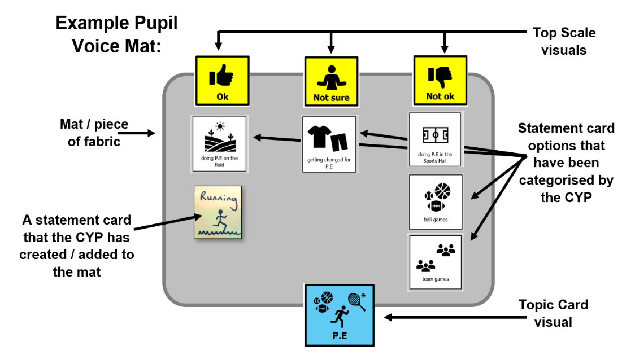
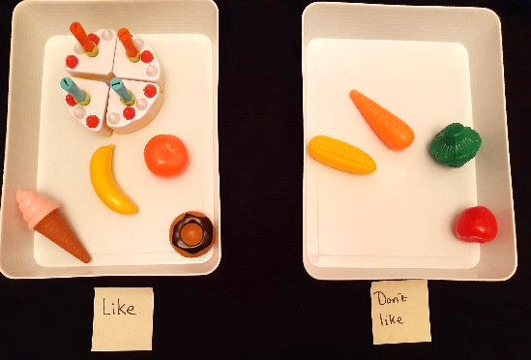
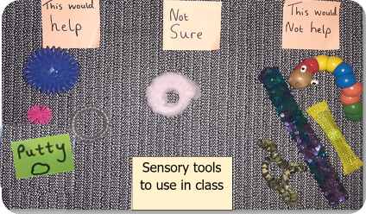

Example ‘Top Scale’ categories:
Please note- Avoid using ‘No Problem’, ‘Little Problem’ and ‘Big Problem’ as ‘Top Scales’, as the double-negative language can be confusing.


- Use of visuals/symbols e.g.:
- Like / Not sure / Don't like
- Happy about / Not sure / Not happy about
- Want to work on / Don't know / Don't want to work on
- Ok / Not sure / Not ok
- Do a lot / Sometimes do / Don't do
- Going well / Sometimes going well / Not going well
- I want this / I'm not sure / I do not want this
- Can do / Need a bit of help / Need a lot of help
- Enjoy / Not sure / Don't enjoy
- This is like me / This is sometimes like me / This is not like me
*Please note: ‘Pupil Voice Mats’ has been inspired by Talking Mats; for further information please visit https://www.talkingmats.com/ .© Talking Mats

‘My Ideal School’
Pupil Voice Activity Overview
Purpose:  - My Ideal School is a pupil voice tool inspired by psychologist Heather Moran; Moran (2001) created a drawing-based technique ('Drawing the Ideal Self') to help CYP better understand themselves and openly share their thoughts by exploring their 'ideal' vs. 'not ideal' characteristics.  - My Ideal School is a flexible and creative pupil voice tool which aims to provide space for CYP to share their views, thoughts and feelings about school e.g. their ideal classroom or ideal breaktime.  - Once the My Ideal School activity is complete, the CYP may be able to rate how close it is to their current situation (and may wish to explore what might help). | 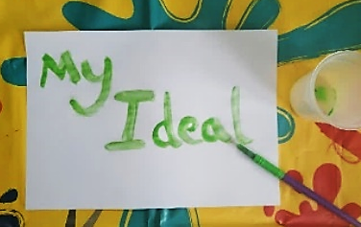
Resources:
- Make sure you have suitable material options ready for the CYP to choose from e.g., bricks, paint, craft supplies, pens, access to technology.
Guidance:
- Estimate how long this activity might take and think about ways to make sure that time is set aside for it (the activity could be a project over several weeks).
- Step 1: Introduce the activity e.g. “I’d like you to try think about your ideal school. That is, something you would really like. I wondered if you would like to make/draw your ideal school? You can be as creative as you like; this is not a real school; you can use your imagination”.
- Step 2: Offer materials e.g. “You can choose any of these materials to create your ideal school”.
- Step 3: Reassure e.g. “I can scribe for you so you can focus on creating your ideal school. There are no right or wrong ideas, and you can stop or take a break at any time.”
- Step 4: Give the CYP time to create their ‘ideal’: As CYP creates their ‘ideal’ and they may share additional information about their creation; listen carefully and note exactly what they say in their own words (either on their project or on a separate piece of paper if they prefer).
- Step 5: Curious questions: If appropriate, the adult may ask curious questions about the CYP’s ‘ideal’ and record the CYP’s response.
- Step 6: Provide an opportunity to add to their ‘ideal’ e.g. “Are you happy with or finished creating your ‘ideal’?” or “Is there anything else you’d like to include?”
- Step 7: Read each statement out loud so the CYP can process and think about what they’ve shared, e.g., “What you’ve told me today is…” (share the notes or labels you’ve written, so they can review and reflect).
- Step 8: Discuss next steps with the CYP e.g. “Thank you for doing the ‘My Ideal School’ activity with me today. It’s really helped me get to know you a bit better. Is there anything on your ‘ideal’ that you’d like to talk more about or anything that I can help with?”, "Is it ok if I take a photo of your ideal school, so I don’t forget?”. Remember— the information gathered should be used to help create tailored support or plans, as part of the graduated approach.
Examples:

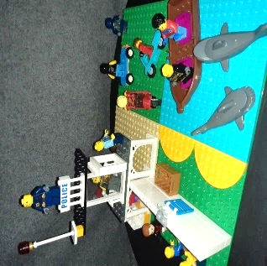
Example curious questions:
“What’s that? / What’s happening here?”
“Why is that important?”
“What is your favourite thing about …?”
“If you were to have this …, how would you feel?”

‘Well-being Wheel’
Pupil Voice Activity Overview
Purpose:
- The Well-being Wheel puts CYP at the heart of identifying their own areas to work on by understanding and prioritising the parts of their life that they would like support with.
- Using the visual framework, the CYP chooses their own priorities, then identifies a ‘baseline level’ on the Well-being Wheel to indicate how they are feeling at present. Through discussion and guided conversation, they may then identify ways in which these 'baseline levels' can improve, which in turn drives the support put in place.
- The Well-being Wheel can then be referred to when reviewing and tracking the outcome progress, as part of the graduated approach.
Resources:
- A blank wheel template or large piece of paper/use of technology to create the wheel.
- Post-it notes and writing materials.
Guidance:
- The wheel can be adapted dependant on the age, stage of the CYP.
- Several options/sections of the wheel may be presented with the CYP only focussing on one or two.
- Step 1: Introduce the activity e.g. "We're going to create (or review) a Well-being Wheel. Here is your wheel." (Place the wheel in front of the CYP). Remember you can pause/stop/pass at any point."​
- Step 2: Explain what the areas of the wheel will be about e.g. "We are going to focus on and explore what you think about _____________". (Show the identified area(s) around the wheel). ​Explain "You can choose something different if you wish".
- Step 3: Explain and position the numbers e.g. "Number 10 is the best it could be, and I don't want anything to change" moving to 1 on a sliding scale. Identify language around these points.
- Step 4: Invite the CYP to discuss the categories one focus at a time e.g. "I have some cards/resources here. If I pass you them, could you place them on the number or write the number on to share your views about how you feel? Please remember there’s no right or wrong. It’s not a test. It’s all about your thoughts and feelings." (Pass each statement card/resource, one by one, to the CYP and ask open ended questions e.g., “Where would you place…?”).
- Step 5: Provide an opportunity for additional statements to be added to the wheel e.g. “Is there anything else you’d like to add to your wheel? I have some post-it notes that you can write/draw on?”.​
- Step 6: Check if the CYP wants to move any numbers e.g. “Are you happy with where everything is on your wheel?”.
- Step 7: Read each statement aloud to allow the CYP to process e.g. “What you’ve told me today is…" (Read out the statements in each category, ending with the things that are working well; allowing the CYP to review, suggest how things can improve and reflect on what that might look like). ​
- Step 8: Discuss next steps with the CYP e.g. “Thank you for doing the Well-being wheel with me today. It’s really helped me get to know you a bit better. Is there anything on your wheel that you’d like to talk more about or anything that I can help with?”, "What do you think would help going forward?".​ Remember— the information gathered should be used to help create tailored support or plans, as part of the graduated approach.
Examples Well-being Wheels:
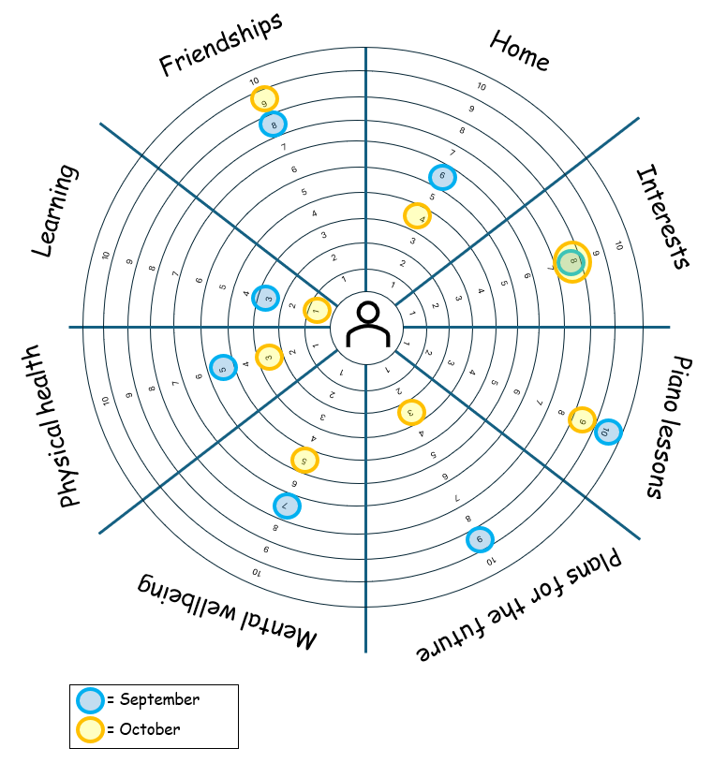
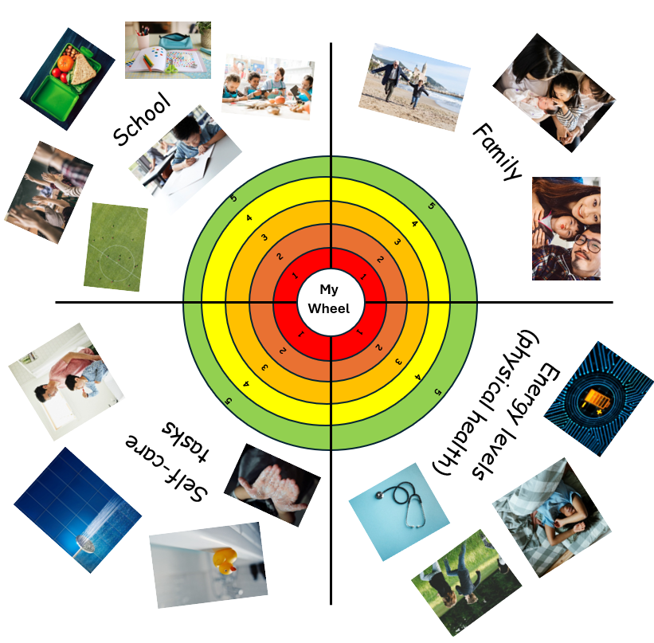

Appendix 1
The voice of CYP is enshrined in law, is essential to safeguarding and supports best practice:

Children have a right to receive and impart information, to express an opinion and to have that opinion taken into account in any matters affecting them from the early years. Their views should be given due weight according to their age, maturity and capability (Articles 12 and 13)
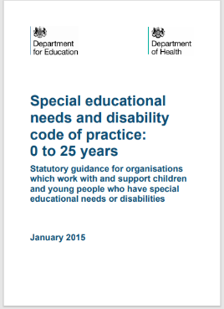

The views of the pupil should be included in these discussions (planning and reviewing progress). This could be through involving the pupil in all or part of the discussion itself or gathering their views as part of the preparation. (6.70)

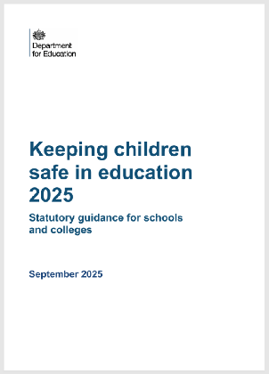
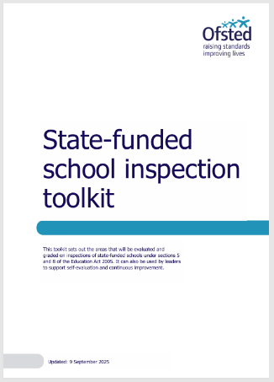
Safeguarding and promoting the welfare of children is everyone’s responsibility. Everyone who comes into contact with children has an important role to play. School and college staff are particularly important as they are in a position to identify concerns early, provide help for children, promote children’s welfare and prevent concerns from escalating. It is important all staff (including those who do not work directly with children) recognise the important role they play in protecting children. (Annexe A)

Inspectors focus on gathering evidence relating to the factors that statutory and non-statutory guidance, research and inspection evidence indicate contribute most strongly to safeguarding e.g., ‘Pupils are kept safe and feel safe. Their voices are heard, including the voices of pupils who are not on the school site (whether long term, temporarily or for part of the school day). Teaching pupils about how they can stay safe and when they may need help is embedded across the curriculum.’ (Grading Safeguarding)

Appendix 2
Examples of potential risks of seeking pupil voice:

